**REPORT ON WIND TURBINE BLADE DESIGN AND ANALYSIS**

**REETH KAWAD**

**B. Sc. Mechanical Engineering**

***Submitted to:* National Institute of Wind Energy,**

**Chennai, Tamil Nadu 600100.**

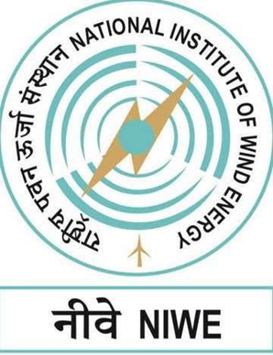

**Mr. S. Paramasivan**

**Assistant Engineer**

**Certification department**

**Date of Submission:**

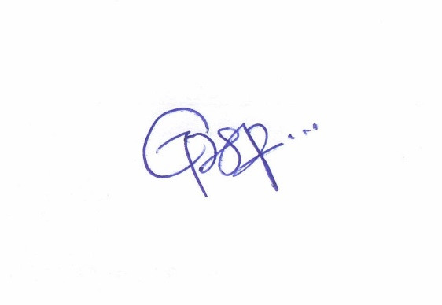

**Signature of Candidate Signature of Mentor**

**ACKNOWLEDGEMENT**

I would like to thank **Dr. RAJESH KATYAL** (Director General) for giving me the opportunity to intern within the organization.

I am highly indebted **SHRI. S. A. Mathew** (Director and Division head Certification and Information Technology) for the facilities provided to accomplish this internship.

It is with a great sense of pleasure and immense sense of gratitude that I acknowledge the help of my Mentor **Mr. S. Paramasivan** (Assistant Engineer in Certification department) for the successful completion of this internship.

I also would like to thank all the people who worked along with me, for their patience and openness, as they created an enjoyable working environment.

I am extremely grateful to my department staff members and friends who helped me with the successful completion of this internship.

Reeth Kawad

**DECLARATION**

This thesis work entitled **“Wind Turbine Blade design and analysis”** is my own work carried out under the guidance of **Shri. S. Paramasivan,** Assistant Engineer. This work in the same form or in any other form is not submitted by me or by anyone else for the award of any degree.

**TABLE OF CONTENTS**

1. INTRODUCTION 9
2. GUIDELINES OF A WIND FARM 12
3. WIND TURBINE 13
   1. Technical terms
   2. Parts of a Wind Turbine
4. WIND BLADE 18
   1. Factors involved in design
   2. Loads on a wind blade
   3. Materials used
   4. Airfoil design
   5. Tools used to aid the design of a wind blade
5. CASE STUDY OF A 2-BLADED TURBINE 32
6. DESIGN PROCESS OF A 5.7M BLADE 37
   1. Airfoil
   2. Design process
7. ANALYSIS OF THE BLADE
   1. Setup
   2. Simulation
   3. Observations and Results
8. CONCLUSION 55
9. REFERENCES 56

**LIST OF FIGURES**

**FIGURE NO: Content**

1. Flow of wind through a turbine
2. Diagram of wind blade with labels
3. Cross section of wind blade to depict moments experienced
4. Top and bottom aeroshell and shear webs
5. Material application via length
6. Labelled diagram of an airfoil
7. Graphs of different parameters along the span
8. Example of the code on a wind blade
9. Typical GUI of GH-Bladed for entering the rotor specification
10. Blade cross section at 3/4th radius
11. Blade profiles
12. Blade chord and twist distribution
13. Power vs wind speed
14. Finite element mesh of the Blade shell
15. Airfoil S809 plotted
16. Airfoil S809 sketch in Solidworks
17. Side view of blade
18. CAD design with each cross section, right-top view
19. Front-top view
20. Front view
21. Side view with dimensions
22. Front view of the solid model of the blade
23. Side view of the solid model of the blade
24. Sectional view of the blade
25. Flowchart to setup Ansys simulation
26. E glass properties
27. Coordinate system of the wind blade
28. Mesh model of the wind blade
29. Total deformation for Moment-x max
30. Eq. stress for Moment-x max
31. Total deformation for Moment-x min
32. Eq. stress for Moment-x min
33. Total deformation for Moment-y max
34. Eq. stress for Moment-y max
35. Total deformation for Moment-y min
36. Eq. stress for Moment-y min
37. Total deformation for Moment-z max
38. Eq. stress for Moment-z max
39. Total deformation for Moment-z min
40. Eq. stress for Moment-z min

**LIST OF TABLES**

**Table No: Content**

1. Parts of HAWT.
2. Position of each cross section
3. Moment load case with results
4. Experimental load cases

**NOMENCLATURES**

HAWT- Horizontal Axis Wind Turbine

NREL- National Renewable Energy Laboratory

TSR- Tip Speed Ratio

O&M- Operation and Maintenance

CFD- Computational Fluid Dynamics

1. **INTRODUCTION:**

The Ministry of New and Renewable Energy (MNRE), Government of India, founded the National Institute of Wind Energy (NIWE) in Chennai in 1998 as an autonomous R&D institution. It is a scientific institution of excellent standards and dedication which offers services and attempts to discover comprehensive solutions to issues and enhancements across all aspects of the wind energy sector. It operates a Wind Turbine Test Station (WTTS) near Kayathir with technical and financial assistance from DANIDA, the Danish Government. The Institute is structured with the following departments to run efficiently:

* **Research & Development (R&D):** The division’s main emphasis is on innovation in the development of parts and sub-systems of wind turbines by collaborating with other institutions.
* **Certification**: The Division carries out Type certification of wind turbines based on IS/IEC 61400-22.
* **Standards & Regulation (S&R)**: The division facilitates Grid Synchronization of wind turbine prototypes and revises the list of Models and Manufactures of wind turbines
* **Skill Development & Training, Infrastructure Management (SDT & IM)**: This division guarantees that the institute has enough data and acts as the best wind energy data hub. It routinely offers national and international training courses for the benefit of stakeholders. PAVAN is a quarterly newsletter that includes current information about the industry and fulfills the need for knowledge.
* **Measurements & Testing (M&T)**: The division creates outstanding testing facilities for entire Wind Turbine Generator Systems (WTGS) in accordance with international standards (IEC). The division provides power evaluation, safety and function testing, load measurements, and other services.
* **Offshore Wind Development, Data Analytics & Forecasting, Information Technology (OWD, DAF & IT)**: The Division is currently engaged in identifying regions abundant in valuable wind resources across the country. Through our comprehensive wind resource micro surveys and the development of a nationwide wind map, we strive to provide wind farm developers with the vital information they need to make informed decisions.

The National Institute of Wind Energy (NIWE) stands as a pioneering institution solely dedicated to the advancement of wind energy technology research, not only within Asia but also across the southern hemisphere.

At NIWE, the inclusive approach encompasses all aspects of wind energy science and technology. Whether you seek assistance with resource assessment, project implementation, or any facet in between, rest assured that the institution is committed to providing the comprehensive support required. With an unwavering commitment to progress, NIWE is poised to chart the most logical and innovative courses that wind energy can undertake.

In summary, NIWE is not merely an institute; it is a dynamic force propelling wind energy technology into the future. With a seasoned team, state-of-the-art infrastructure, and an open-door policy to all things wind energy, NIWE is poised to drive innovation, promote sustainability, and serve as a beacon of expertise in the realm of wind energy technology, both at home and on a global scale.

The wind energy potential in our country is indeed substantial, with considerable resources available at different altitudes. At a height of 100 meters above ground level, we have identified an impressive wind potential of 302 GW, and this rises to an even more remarkable 695.50 GW at 120 meters above ground level. Furthermore, our assessments indicate significant wind energy potential at lower altitudes as well, with 49,130 MW at 50 meters and 102,788 MW at 80 meters above the ground. Despite this immense potential, achieving the full utilization of wind energy has encountered certain challenges and limitations.

The concept of "rated power" represents the optimum power output we aspire to achieve from a wind turbine. This serves as our target under perfect conditions. However, real-world factors introduce complexities that often prevent us from attaining this theoretical ideal.

Variable wind speeds, blade weariness, and O&M collectively contribute to deviations from the rated power. These factors are inherent challenges that necessitate careful consideration and management.

The centerpiece of a wind turbine’s performance is undeniably its blade. As we endeavor to harness greater power yields at elevated heights, the design and construction of turbine blades become progressively intricate. Striving for enhanced power necessitates the development of blades capable of withstanding higher wind velocities, addressing material fatigue, and navigating other engineering complexities.

My internship at NIWE involved the research of the complete design of a wind turbine blade. To understand every aspect, from the materials used to attempting to design and analyze a wind blade using professional software’s, Solidworks and Ansys.

**2.0. GUIDELINES OF A WIND FARM:**

To motivate the development of renewable energy in India despite the high setting up cost, the Government of India set up some policies:

* Concession on import duty on specified wind turbine components such as nacelle, rotor and wind turbine collector
* 10 year income tax holiday for wind power generation projects
* Concessional custom duty exemption on certain components of wind electric generators
* 100% exemption from excise duty on certain wind turbine components.
* REC Mechanism.
* Waiver of Inter State Transmission System (ISTS) charges and losses for inter-state sale of solar and wind power for projects to be commissioned up to March, 2022.
* Permitting Foreign Direct Investment (FDI) up to 100 percent under the automatic route.
* Notification of standard bidding guidelines to enable distribution licensee to procure wind power at competitive rates in cost effective manner.
* Declaration of trajectory for Renewable Purchase Obligation (RPO) up to the year 2022.
* Implementation of Green Energy Corridor project to facilitate grid integration of large-scale renewable energy capacity addition.
* Technical support including wind resource assessment and identification of potential sites through the National Institute of Wind Energy, Chennai.
* IREDA finance scheme for wind power projects.
* Special incentives provided for promotion of exports from India for various renewable energy technologies under renewable sector specific SEZ.
* Feed-in-Tariff (FIT) scheme for wind projects upto 25 MW.
* Accelerated Depreciation – ended in 2017
* GBI scheme for grid interactive wind power projects commissioned before 31 March 2017.

**3.0. WIND TURBINE:**

A wind farm is only as good as the wind turbine. The wind turbine works on the simple principle of converting energy stored in wind to electricity. The wind spins the blades of the turbine which spins a generator.

Wind flow patterns are modified by bodies of water, vegetation, and terrain differences. The flow of wind across the blade creates a pressure difference on either side of the blade. This creates lift and drag; lift being stronger, which causes the rotor to spin. While it seems like a straightforward process, to achieve high power as high as 10 MW, requires wind blades as long as 100m and a complex system of gearboxes, and other mechanical innovations to overcome the engineering and logistical difficulties. It is a beautiful amalgamation of mechanical design in the aspect that it maximizes the swept area, produces torque despite low wind speeds and turbulence, and electrical architecture. To understand it in depth, it is important to understand some technical and physics terms related to wind energy and the working of wind turbines.

This comprehensive approach highlights the complexities and innovations involved in the wind energy industry, emphasizing the need for advanced engineering solutions to harness wind power effectively.

* 1. **Technical terms:**

Factors involved in wind turbine and blade mechanics:

1. Lift- force on the blade due to the pressure difference between upper and lower surfaces. It is perpendicular to airflow.
2. Drag- resistance parallel to airflow, which is caused by friction and pressure forces.
3. Angle of attack- angle between the chord line and the direction of airflow. Adjusting it helps control the lift and drag.
4. Reynolds number- ratio of inertial and viscous forces in fluid flow. It helps the predict behaviour of airflow around blade. Fluid density, velocity, viscosity, and chord length are used to calculate it.
5. Stall- When the angle of attack is greater than the threshold, there is sudden decrease in lift and increases in drag resulting in a disruption of smooth airflow. An airfoil should allow soft stall, not hard.
6. Turbulence- chaotic patterns in the wind,
7. Boundary layer- thin layer of air surrounding the blade surface. We understand its behaviour for minimum drag.
8. Cl/Cd- represents the efficiency of a blade, higher the better.
9. Tip speed ratio (TSR)- ratio of blade tip speed and wind speed. It is the relative speed of blade through wind
10. Power output- amount of kinetic energy to mechanical/electrical energy. It is directly related to wind speed, swept area and efficiency of turbine.
11. Efficiency- ratio of power output and maximum power output
12. Air density- temperature and altitude are the main factors. Cold and low altitude have a higher air density than warm and high altitude.
13. The Mach number- dimensionless quantity that is used to characterise the speed of a fluid relative to the speed of sound. The Mach number affects the way that air flows over an airfoil, and it can have a significant impact on the airfoil's performance at high speeds.
14. Mass   
    v = wind speed

A =blade area

rho= air density

flow = vA(rho)

Mass flow contains energy which is used by the turbine to conduct electricity.

Energy depends on mass and speed.

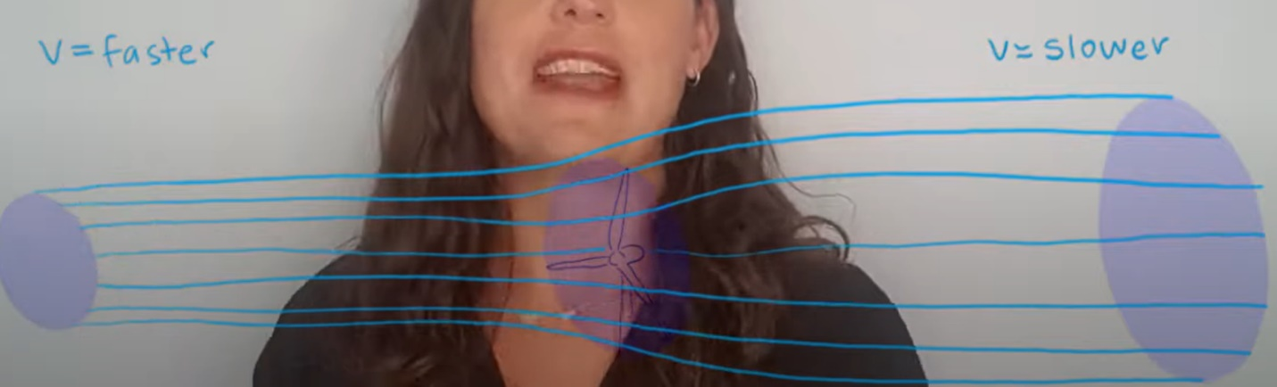

*Figure 1. Flow of wind through a turbine*

Consider it a stream tube. Mass at any cross section is the same.

After going through the turbine, some energy is captured by the turbine. E = ½mv2. Since mass does not change, v changes. It becomes slower.

Efficiency cannot be 1 because that would mean wind would stop at the wind turbine and air particles would stick on the turbine blade.

1. Betz limit- it is the maximum efficiency any wind turbine can achieve = 59%
2. Blade spar- structural element along length that provides strength and stiffness.
3. Pitch system- mechanism which adjusts angle of attack by rotating the blade abut its axis.

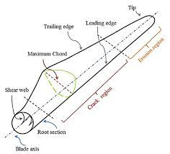

*Figure 2. Diagram of wind blade with labels*

* 1. **Parts of a Wind Turbine:**

There are multiple parts of this machine made up of different materials The table below shows the parts of a HAWT and their function.

**Table 1:** Parts of HAWT.

|  |  |  |  |
| --- | --- | --- | --- |
| **Sl.No** | **Name** | **Function** | **Logic behind build** |
| 1. | Turbine tower | Supports the turbine | Made of tubular steel, comes in 3 sections and assembled on-site |
| 2. | Wind vane | Measures wind direction and contacts the yaw drive to position accordingly | Mounted on the tower at the opposite end of the rotor |
| 3. | Anemometer | Measures wind speed and sends the data to the controller | Sits along with the wind vane |
| 4 | Blade | Capture the energy from the wind and use it to spin the rotor | Mostly made of fiberglass, and in 2 or 3 in number |
| 5. | Nacelle | Contains the gearbox, low and high speed shafts, generator and brake | Size is sometimes as large as a house |
| 6. | Yaw system | Rotates the nacelle to keep it facing the wind as the direction changes | They are powered by the yaw motor. Required for upwind turbines only |
| 7. | Pitch system | Adjusts the angle of blade to maximizes energy extraction | Placed in the rotor |
| 8. | Hub | Holds the drivetrain and blades and connects it to the main shaft |  |
| 9. | Gearbox | Converts the low speed rotation of the turbine into electrical energy | Comprises of the rotor, main bearing, main shaft, gearbox and generator |
| 10. | Rotor | Blades and hub together |  |
| 11. | Low speed shaft | Rotates along with the low speed rotor | Part of the drivetrain and spins between 8-20 rpm |
| 12. | Main shaft bearing | Reduces friction between moving parts inside the drivetrain so the forces from rotor don’t damage the shaft | Part of the drivetrain |
| 13. | High speed shaft | Connects gearbox and drives the generator | Part of the drivetrain |
| 14. | Generator | Produces electricity from the rotation of the high speed shaft | Copper windings, driven by the gearboxes, rotate through a magnetic field |
| 15. | Controller | Ensures that machine does not run at too low (<7mph) or high speeds(>60mph) | Acts like the nervous system. Turns on the machine only with the speed range |
| 16. | Brake | Keeps the blade from turning after controller stops the blade | Required for maintenance |

1. **WIND BLADE**

**4.1. Factors involved in the design**

Before we start designing the blades of a wind turbine, it is important to understand the factors involved. It is a complex process that involves considerations from various engineering disciplines. It is necessary to ensure optimal performance, structural integrity and safety. Designing a wind turbine blade is a complex process that involves considerations from various engineering disciplines. Numerous factors influence the design to ensure optimal performance, structural integrity, and safety. Here are some key factors that affect the design of a wind turbine blade:

* 1. Aerodynamic factors:
     1. Blade Shape: The aerodynamic profile and shape of the blade impact its ability to capture wind energy efficiently.
     2. Airfoil Selection: Choosing appropriate airfoils for different blade sections affects lift, drag, and overall performance.
     3. Angle of Attack: The angle at which the blade meets the wind affects lift and drag forces.
  2. Wind Conditions:
     1. Wind Speed: The turbine’s location and expected wind conditions determine the loads the blade will experience.
     2. Turbulence: Turbulent wind conditions affect fatigue loads and blade dynamics.
  3. Structural Considerations:
     1. Material Selection: The choice of composite materials, like fiberglass or carbon fiber, affects strength, weight, and durability.
     2. Blade Geometry: Blade length, chord length, twist angle, and curvature influence the structural behavior and energy capture.
     3. Load Distribution: Proper load distribution across the blade’s length helps prevent overloading and fatigue.
  4. Rotor Design:
     1. Rotor Diameter: Blade length impacts the swept area and overall power output.
     2. Hub Design: The hub connects the blade to the rotor, influencing load distribution and structural integrity.
  5. Environmental Factors:
     1. Temperature: Variations in temperature affect material properties and thermal expansion.
     2. Humidity: Moisture can impact material degradation over time.
  6. Manufacturability:
     1. Manufacturing Process: The method used to create the blade impacts its quality, cost, and structural properties.
     2. Mold Design: The blade’s shape is formed using molds, and mold design influences precision and repeatability.
  7. Dynamic Behavior:
     1. Vibration and Resonance: Blade dynamics, vibrations, and resonance need to be controlled to prevent damage and noise.
     2. Damping: Effective damping minimizes oscillations and vibrations.
  8. Safety and Certification:
     1. Certification Standards: Blades must adhere to industry standards and regulations to ensure safety and reliability.
     2. Load Cases: Blades must be designed to withstand various load cases, including extreme conditions.
  9. Operational Considerations:
     1. Pitch Control: The ability to adjust blade pitch optimizes energy capture and turbine stability.
     2. Yaw Control: The rotor’s orientation to the wind affects load distribution.
     3. **Different loads on a wind blade:**

Wind turbine blades experience several types of loads. These loads are a result of the complex interaction between the blade, the wind, and the turbine’s operation. Here are the different types of loads that act on a wind turbine blade:

* + - 1. Aerodynamic Loads:
         1. Lift: The aerodynamic force perpendicular to the wind direction, responsible for generating lift and supporting the weight of the blade.
         2. Drag: The aerodynamic force parallel to the wind direction, opposing the motion of the blade and causing drag.
      2. Gravity Loads: Weight- The gravitational force acting vertically downward on the blade.
      3. Centrifugal Loads: Generated due to the rotation of the rotor, causing outward forces on the blade.
      4. Bending Loads:
         1. Edgewise Bending: Bending loads along the rotor axis (x-direction) due to the aerodynamic and centrifugal forces.
         2. Flap-wise Bending: Bending loads perpendicular to the rotor axis (y-direction) due to the aerodynamic and centrifugal forces.
      5. Torsional Loads: Twisting loads along the blade’s length (z-direction) due to variations in wind conditions across the span.
      6. Fatigue Loads: Cyclic Loading- Wind conditions change over time, leading to cyclic loading that can result in fatigue failure over the blade’s operational life
      7. Extreme Loads:
         1. Start-Up and Shut-Down Load- Blades experience significant loads during start-up and shut-down due to the change in wind speed and rotor dynamics.
         2. Extreme Wind Conditions: Blades must be designed to withstand high winds and extreme weather events, ensuring they do not exceed safe operating limits.
      8. Dynamic Loads: Interactions between the blade’s natural frequencies, rotor speed, and turbulent wind conditions can lead to dynamic loads and vibrations.
      9. Shear Loads: Forces that act parallel to the blade’s surface and can lead to material deformation and structural stress.
  1. Thermal Loads: Changes in temperature can lead to thermal expansion and contraction, affecting material properties.
  2. Icing Loads: Ice build-up on the blade surface can increase its weight and alter its aerodynamic behavior, leading to unbalanced loads.
  3. Manufacturing and Transport Loads: Loads experienced during blade manufacturing, transportation, and installation.

Wind turbine blades are designed to withstand these various loads while maximizing energy capture, minimizing structural fatigue, and ensuring safe and reliable operation. Advanced analysis techniques, such as finite element analysis (FEA), computational fluid dynamics (CFD), and field testing, are used to simulate and validate the blade’s response to these loads. We will discuss other tools used in more detail. Further, the report will conduct analysis on a wind blade by simplifying these loads into a single moment for approximate results.

* + 1. **Loads faced on different span regions**

In wind turbine blade design, the blade is divided into three regions: the root region, intermediate region, and tip region. These regions have distinctive characteristics and face varying loads due to their positions along the length of the blade and their roles in capturing wind energy efficiently. Here is an overview of each region and the types of loads they typically encounter:

* + - 1. Root Region:
         1. Location: The root region is the portion of the blade closest to the hub of the wind turbine, where the blade is attached to the rotor hub.
         2. Characteristics: It is built thicker and more heavily compared to the tip region. It has a higher chord length.
         3. Loads: The region primarily experiences axial and bending loads. These loads are transmitted from the hub to the blade and can be substantial. The root also experiences torsional loads due to changes in wind direction.
      2. Intermediate Region:
         1. Location: The intermediate region is located between the root and tip regions, in the middle of the blade length.
         2. Characteristics: It is thinner than the root region but thicker than the tip region. The chord length is moderate.
         3. Loads: The intermediate region primarily experiences bending loads due to the flexing of the blade under wind forces. It also contributes to the overall lift generation.
      3. Tip Region:
         1. Location: The tip region is the outermost portion of the blade, farthest from the hub.
         2. Characteristics: It is relatively thin and has a shorter chord length.
         3. Loads: The tip region primarily experiences aerodynamic forces, including lift and drag. These forces are responsible for the majority of the energy capture by the wind turbine. It also experiences bending loads but to a lesser extent than the root and intermediate regions.

In summary, the variations in thickness along a wind turbine blade are a result of a careful balance between structural requirements, aerodynamic efficiency, and load distribution. Each region is designed to perform specific functions while maximizing the overall energy capture and efficiency of the wind turbine.

* 1. **Materials used:**

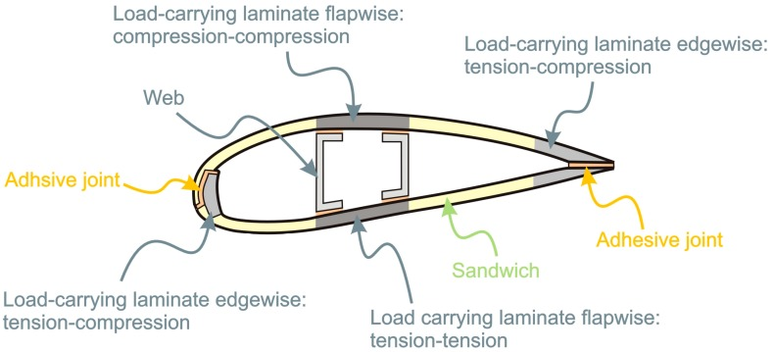

*Figure 3. Cross section of wind blade to depict moments experienced*

A cross-section of a wind turbine blade is a critical element in understanding how loads are applied to different parts of the blade and how the blade's structural design should accommodate these loads, as demonstrated in Figure 3. The cross sections reveals:

1. Load Distribution: Exhibits how aerodynamic forces, including edgewise and flapwise moments, are distributed along the span of the blade, in turning helping understand which sections of the blade experience higher or lower loads.
2. Material Selection: Based on load distribution, informed decisions about the type and properties of materials to use in different regions of the blade can be made.
   1. Root Region: Typically subjected to high bending moments, so materials with high stiffness and strength are used.
   2. Midspan Region: May experience a combination of bending and torsional loads, requiring materials with appropriate mechanical properties.
   3. Tip Region: Often subject to flapwise bending, necessitating materials that can handle high tensile and compressive loads.
3. Optimized Design: By analyzing the load distribution, engineers can optimize the blade's design to ensure it meets performance and safety requirements while minimizing material usage and weight.
4. Structural Analysis: Engineers use this information to conduct structural analysis, including finite element analysis (FEA), to simulate how the blade responds to loads and refine the design for structural integrity.
5. Performance Enhancement: Understanding load distribution helps in the development of advanced blade designs, such as those with twist, taper, or aerodynamic features, to improve overall turbine performance.

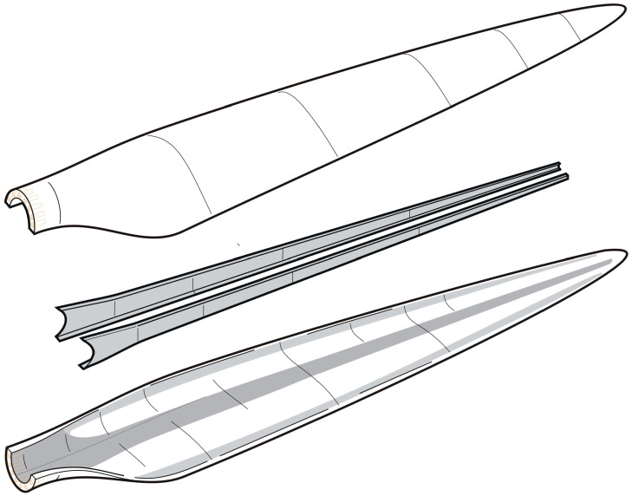

*Figure 4. Top and bottom aeroshell and shear webs*

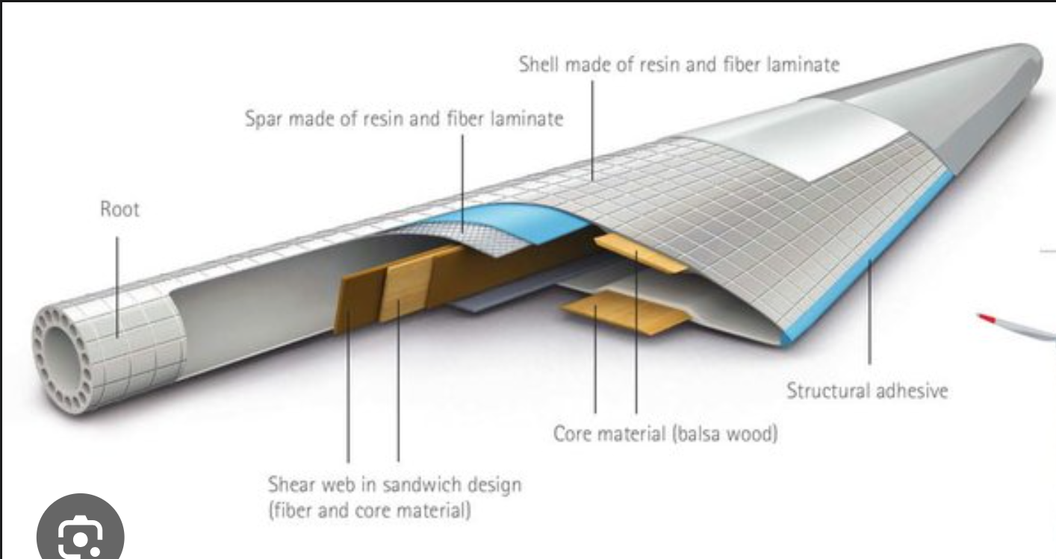

*Figure 5. Material application via length*

Figure 5. gives a detailed description of how and which different materials are used at the root and along the length of the blade.

The fiber material that the wind blade is made up of must be structurally strong but light. Normally, a material with anisotropic properties is preferred for wind turbine blades so that they can be tailored to have specific material properties in the directions that are most critical for blade performance. In contrast, isotropic materials have the same mechanical properties in all directions. The following material properties, isotropic materials, define how they affect the blade, and what their ideal values should be:

1. Density: The density of the material impacts the overall weight of the blade. Lower density materials reduce the weight of the blade, which can improve efficiency, reduce structural stress, and minimize the load on the turbine’s gearbox and tower. The ideal values would range around 2,000 kg/m3.

2. Young's Modulus (E): Young's Modulus measures a material's stiffness and its ability to deform elastically when subjected to a load. A higher Young's Modulus indicates greater stiffness, which is essential for maintaining the blade's shape and minimizing deflection under load. The ideal value for a wind blade can range from anywhere between 30 to 120 GPa.

3. Poisson's Ratio (ν): Poisson's Ratio describes the material's tendency to contract laterally when stretched longitudinally (or vice versa). The ratio affects how materials deform under load and can impact blade behavior and stress distribution. For a wind blade, the value should be within the range of 0.2-0.35.

4. Bulk Modulus (K): Bulk Modulus quantifies a material's resistance to volumetric compression. It influences the material's response to changes in pressure or load and can affect blade deformation. The ideal values fall within the range of 10-20 GPa.

5. Shear Modulus (G): Shear Modulus measures a material's resistance to shearing forces. It's crucial for assessing the material's ability to withstand shear stresses experienced during blade operation. The material used should have a value between 10-40 GPa.

6. Tensile Ultimate Strength: This property represents the maximum stress a material can withstand before it fails under tension. It's essential for assessing the blade's structural integrity and its ability to withstand extreme wind loads. The ideal value falls between 100-300 MPa.

7. Tensile Yield Stress: Tensile Yield Stress indicates the stress level at which the material begins to deform plastically without full failure. It's vital for understanding the material's behavior when subjected to loads below its ultimate strength. Tensile yield stress should be a little lower than tensile ultimate strength. It helps in analyzing the blade and determining the break point of the blade.

Selecting materials with appropriate combinations of these properties is critical in wind blade design. The goal is to achieve a balance between stiffness, strength, weight, and other factors to ensure the blade can efficiently capture wind energy while remaining structurally sound throughout its operational life.

* 1. **Airfoil design:**

An airfoil is a cross-sectional shape of an aircraft wing or other lifting surface, like the wind turbine blade. The shape of an airfoil is designed to create a pressure difference between the top and bottom surfaces, which generates lift. There are many existing airfoil designs after thorough research by research institutions and government to produce the highest life for different situations.

The following are some of the factors involved in airfoil design:

* Camber: It is the difference in height between the upper and lower surfaces. It is important for generating lift, and the amount of camber required depends on the application.
* Thickness: It affects the lift and drag characteristics. Thicker airfoils produce more lift, but they also have more drag. It is also important for structural considerations.
* Twist: It is the change in angle of attack along the length of the airfoil. Twist is important for ensuring that the airfoil produces lift evenly across its entire length.
* Taper: It is the change in chord length along the length of the airfoil. It is necessary for minimizing drag.

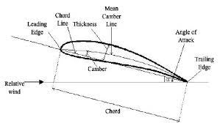

*Figure 6. Labelled diagram of an airfoil*

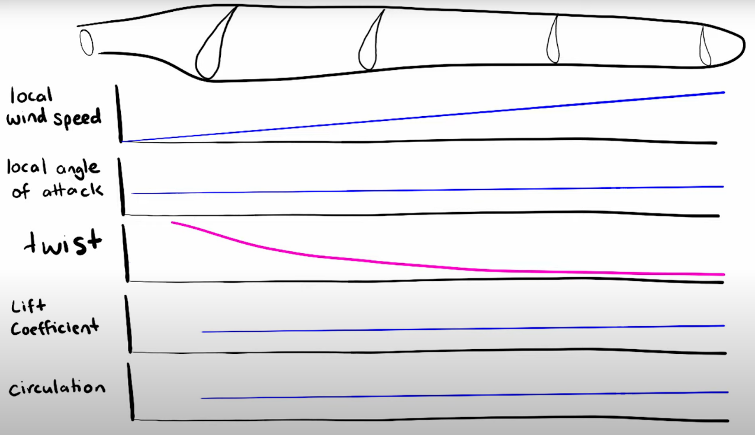

*Figure 7. Graphs of different parameters along the span*

Additionally, the Reynolds number, Mach number, and boundary layer are crucial factors that significantly influence the aerodynamic performance of an airfoil.

Lower Reynolds numbers tend to promote laminar flow, while higher Reynolds numbers favor turbulent flow. As Reynolds number changes, boundary layer transition points and drag behavior also change, influencing blade efficiency and aerodynamic performance.

Mach numbers are significantly below 1. Wind turbine blades usually operate at low Mach numbers, and compressibility effects are negligible. However, it is important to account for any potential transonic or supersonic regions, especially near the blade tips, to prevent unwanted aerodynamic phenomena.

The design of an airfoil is a complex process that requires a deep understanding of aerodynamics and fluid dynamics. Engineers use a variety of tools and techniques to design airfoils, including:

* Computational fluid dynamics (CFD): CFD software can be used to simulate the flow of air over an airfoil and predict its aerodynamic performance.
* Wind tunnel testing: Wind tunnel testing can be used to measure the aerodynamic performance of an airfoil under controlled conditions.
* Experimental testing: Experimental testing can be used to validate the results of CFD and wind tunnel testing.
  1. **Tools used to aid the design of a wind blade:**

1. 2D IMPRANS CFD code
   1. IMPRANS is a RANS Solver for Unsteady Compressible Flows.
   2. It is used to evaluate Cl and Cd, and stall onset

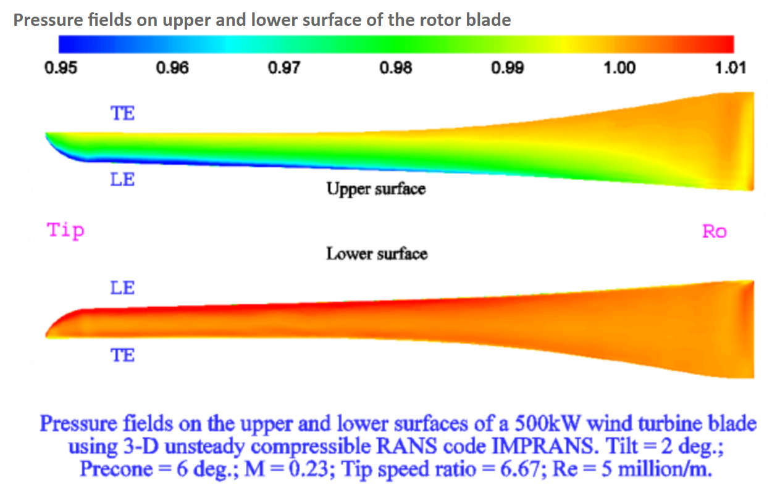

*Figure 8. Example of the code on a wind blade*

1. EPPLER Code
   1. It is set up in the Public domain Aeronautical Software for the use of airfoil shapes
   2. It is a combined method comprising of conformal mapping method with velocity-distribution characteristics, panel method for analysis of potential flow, and boundary-layer method
   3. It is very efficient and successful for Re: 30k- 50million
2. 3D IMPRANS, GH-Bladed and TANGLER codes
   1. Used for aerodynamic analysis, to quantify rotor performance, load spectrum, rotor performance and power coefficient
   2. IMPRANS- Implicit Reynolds Averaged Navier Stokes solver- in house CFD (2D and 3D) at NAL (National Aerospace Laboratory)
   3. HAWTPP- horizontal axis wind turbine performance prediction code
   4. GH- BLADED- conducts range of performance and loading calculations
      1. Main Features:
         1. Multi-Disciplinary Analysis: GH-Bladed enables the analysis of various aspects of wind turbine operation, including aerodynamics, structural/mechanical control, and electrical dynamics.
         2. Advanced Simulation: The software provides detailed simulation capabilities for scenarios such as low voltage ride-thru, grid loss, and short circuit faults.
         3. Grid Code Compliance: GH-Bladed ensures that wind turbines comply with grid codes, which are regulations and requirements set by power grid authorities.
         4. Conceptual Electrical System Design: The software supports the conceptual design of wind turbine electrical systems, including the integration with the grid.
      2. Rotor:
         1. Rotor Configuration: GH-Bladed allows users to define rotor characteristics, including tilt and cone angles, the number of blades (1, 2, or 3), hub type (fixed or teetered), wind direction (upwind or downwind), and rotation direction (clockwise or anticlockwise).
         2. Rotor Imbalances: The software considers rotor mass, geometric variations, and pitch imbalances that can affect turbine performance.
      3. Blade Properties:
3. Blade Control: GH-Bladed enables the simulation of full or partial span pitch or aileron control, allowing for control strategies to optimize turbine performance.
4. Blade Geometry: Users can define blade sweep and pre-bend characteristics that impact aerodynamic behaviour.
5. Aerofoil Interpolation: The software provides comprehensive interpolation capabilities for aerofoil data, which is essential for accurate aerodynamic simulations.
6. Vibration Dynamics: GH-Bladed considers blade vibration dynamics, helping to understand and mitigate vibration-related issues.
7. Iced Blades: The software models the impact of ice accumulation on blades, which can affect aerodynamics and performance.
8. Vibration Dampers: GH-Bladed allows users to simulate the effect of vibration dampers on blade behaviour.
9. Encryption: The software provides an encryption facility for blade and aerofoil data, ensuring data security and protection of proprietary designs.

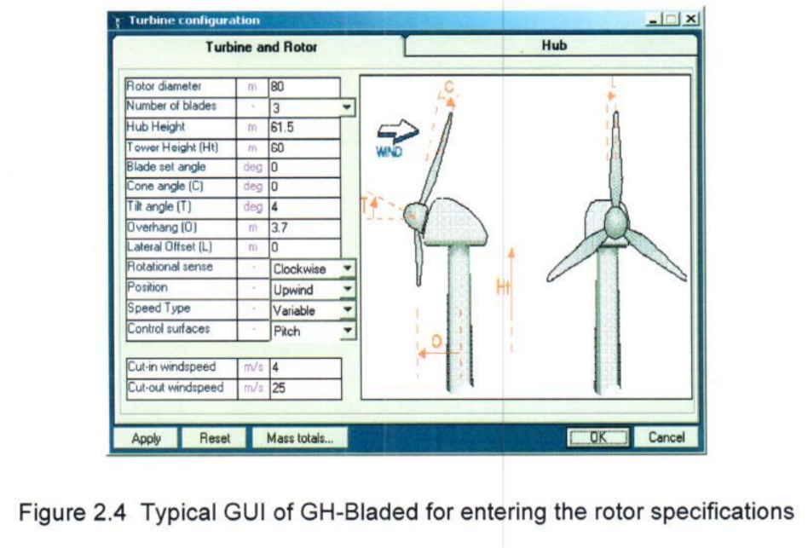

*Figure 9. Typical GUI of GH-Bladed for entering the rotor specification*

1. Xfoil- Simulation tool to determine airfoil characteristics such as shape, lift, drag and stall
   1. **CASE STUDY OF A 2-BLADED TURBINE**

The section will primarily focus on the design of the turbine blade. This is a case study of the wind turbine blade submitted by Centre for Wind Energy Technology (C-WET), now known as National Institute of Wind Energy (NIWE). It is a wind turbine blade for low and moderate wind regimes. The turbine is rated 300kW. It has the following features:

1. It has 2 blades each of 12m.
2. The blades are teetered, made flexible to relieve unnecessary loads.
3. The two major parts are the: surface aka shell and spar bonded at the tip.
   1. The shell is made of glass or epoxy laminates sandwiched with foam.
   2. The spar is of the length 5m with an I cross section and fiber is laid along the length.
4. There is an electromagnetic actuator which keeps the blade at 0o pitch and when it is deactivated it goes to 25o, which sets the blade for aerodynamic braking.

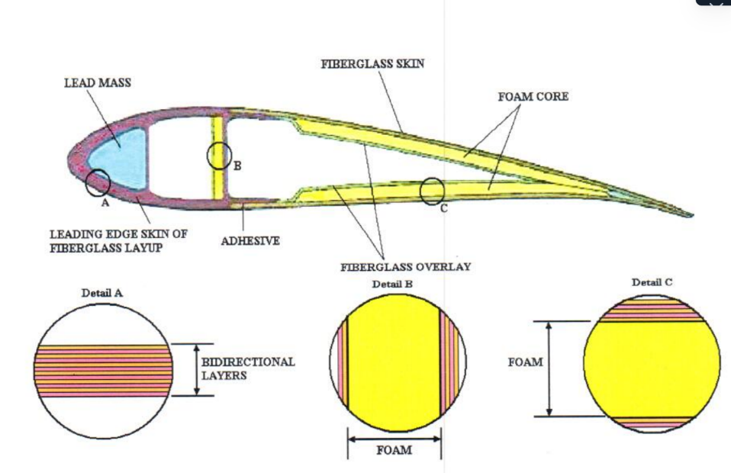

*Figure 10. Blade cross section at 3/4th radius*

From the figure, we can see how the different layers are composed of different materials. Aerodynamics of the blade:

* Laminar regime:
  + at 19m/s, the blade generates a thrust of 38kN and produces 249 kW of power.
  + at 30m/s, the blade generates a thrust of 50kN and produces 314kW of power.
* Turbulent regime:
  + At higher wind speeds, the blade generates a thrust of 50kN and 257kW of power.
* This data was evaluated by the BLADED code, a common tool in wind turbine analysis and simulation. It is used for structural dynamics, powertrain dynamics, closed-loop control, wind modeling, and post processing data.
  + Data required to use the code:
    - Aerofoil section coefficients- lift, drag, and moment coefficients of the airfoil sections. Lift and drag coefficients are sourced from NASA reports.
    - Blade properties like the blade geometry, material properties and structural characteristics.
    - Turbine rotor and hub specifications

Design:

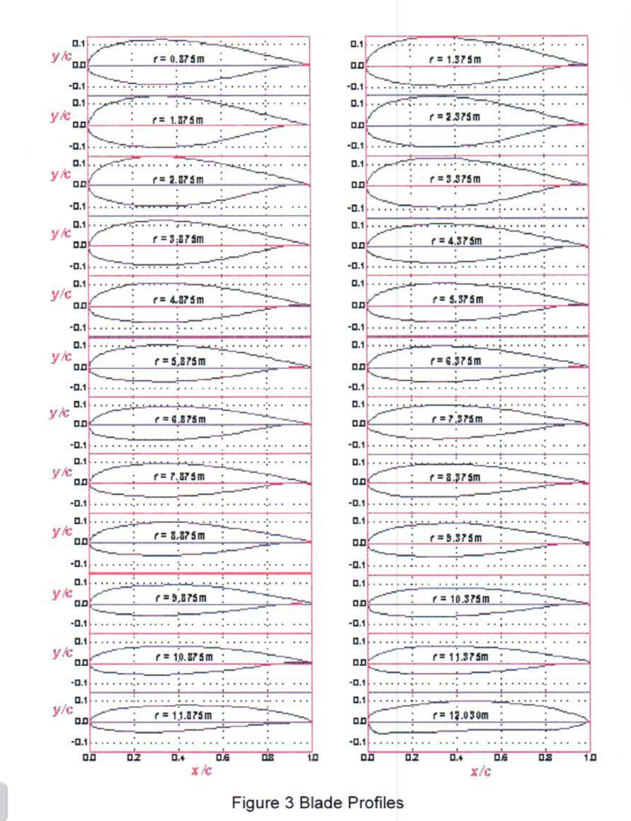

*Figure 11. Blade profiles*

Figure 11. depicts the blade profiles at 24 cross sections. r stands for the distance from the root, the span of length at which the cross section is at.

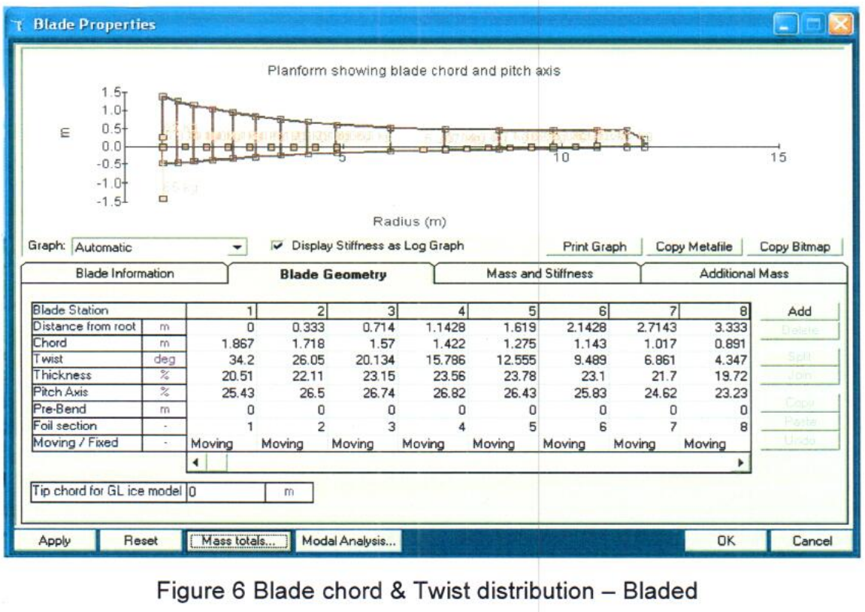

*Figure 12. Blade chord and twist distribution*

Figure 12. shows a side view of the blade. It is a screenshot obtained from BLADED code. All details involved that affect the blade’s performance are distinctly mentioned. We also see where cross sections from figure 11. stand in the span.

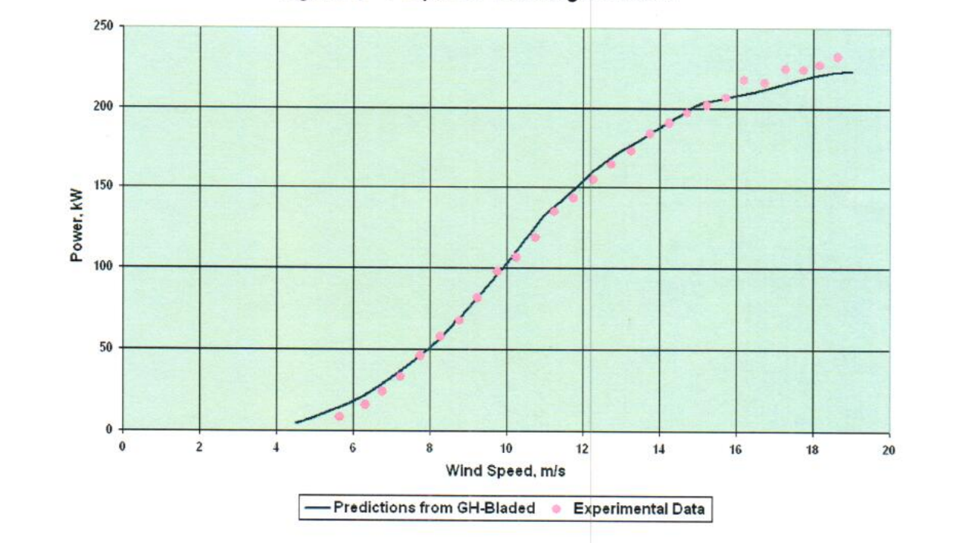

*Figure 13. Power vs wind speed*

Figure 13. proves the accuracy of GH Bladed code, by showing how close the experimental data and prediction are. We also notice that when the wind speed doubles from 8 m/s to 16 m/s the power increases by a factor of 4. But since it is not a linear graph, we cannot establish the power and wind speed relation by a constant term. We also notice that after a certain speed the power output starts becoming constant. It proves that after a threshold wind speed, the power would not increase; in fact, at very high speeds, it might even decrease.

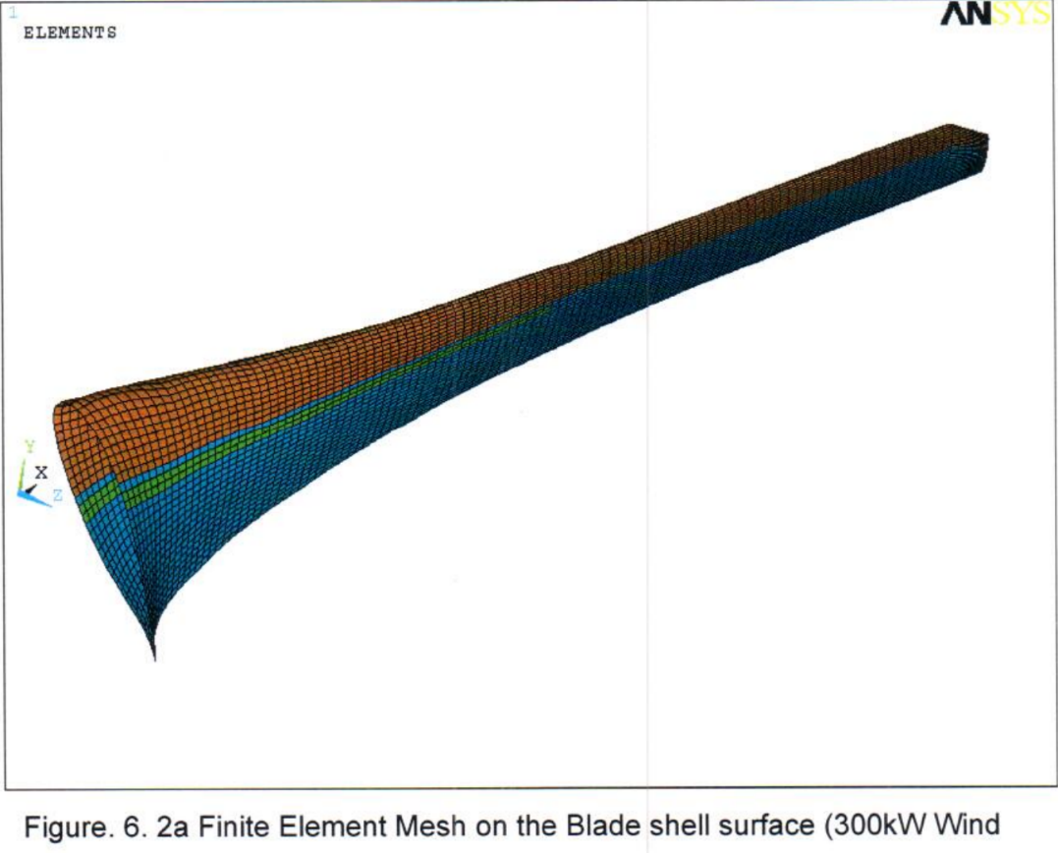

*Figure 14. Finite element mesh of the Blade shell*

After designing a wind blade, it is necessary to run a finite element analysis to understand how the blade performances under the different forces. This is necessary for design optimization, and to ensure that before manufacturing the blade is at maximum efficiency. Figure 14. shows the Finite element mesh of a section of the blade. The mesh shape is hexahedral. Hex mesh allows for more accurate simulations due to their high resolution and consistent unit size. The aim of any computer aided design is to be sliced into different sections and provide a smooth hex mesh. When a design meshes without any extraneous errors, it shows the feasibility of the design.

* 1. **DESIGN PROCESS OF A 5.7M BLADE**
  2. **Airfoil selection**

Assumption: Wind resource assessment has been conducted. The land available has been assessed and the length of the blade has been decided to be between 5-6m. The wind blade design is for low to moderate speed.

Once all the data is accumulated, it is necessary to decide the airfoil type. The Airfoil Tools website is a database of existing airfoils, from National Advisory Committee for Aeronautics (NACA) and International Universities like the Delft University (DU). It provides the coordinates of a 2D plane as shown in Figure 15. and 16, and all necessary data to design an airfoil- maximum thickness, maximum camber and the span length at which they stand. It also provides the max Cl/Cd at different Reynolds numbers.

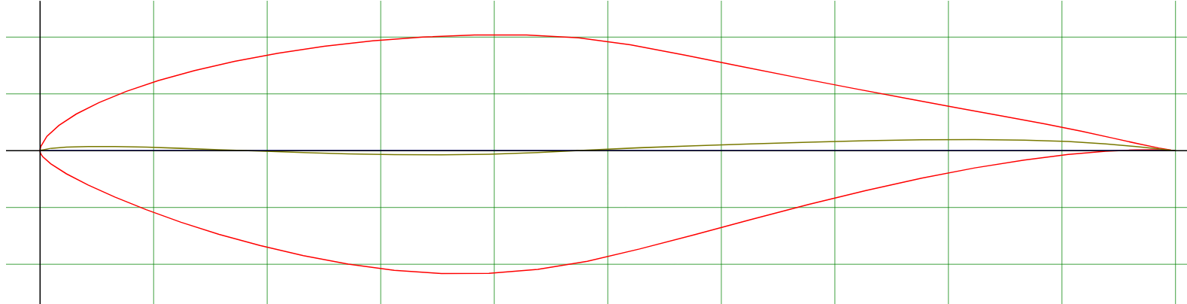

*Figure 15. Airfoil S809 plotted*

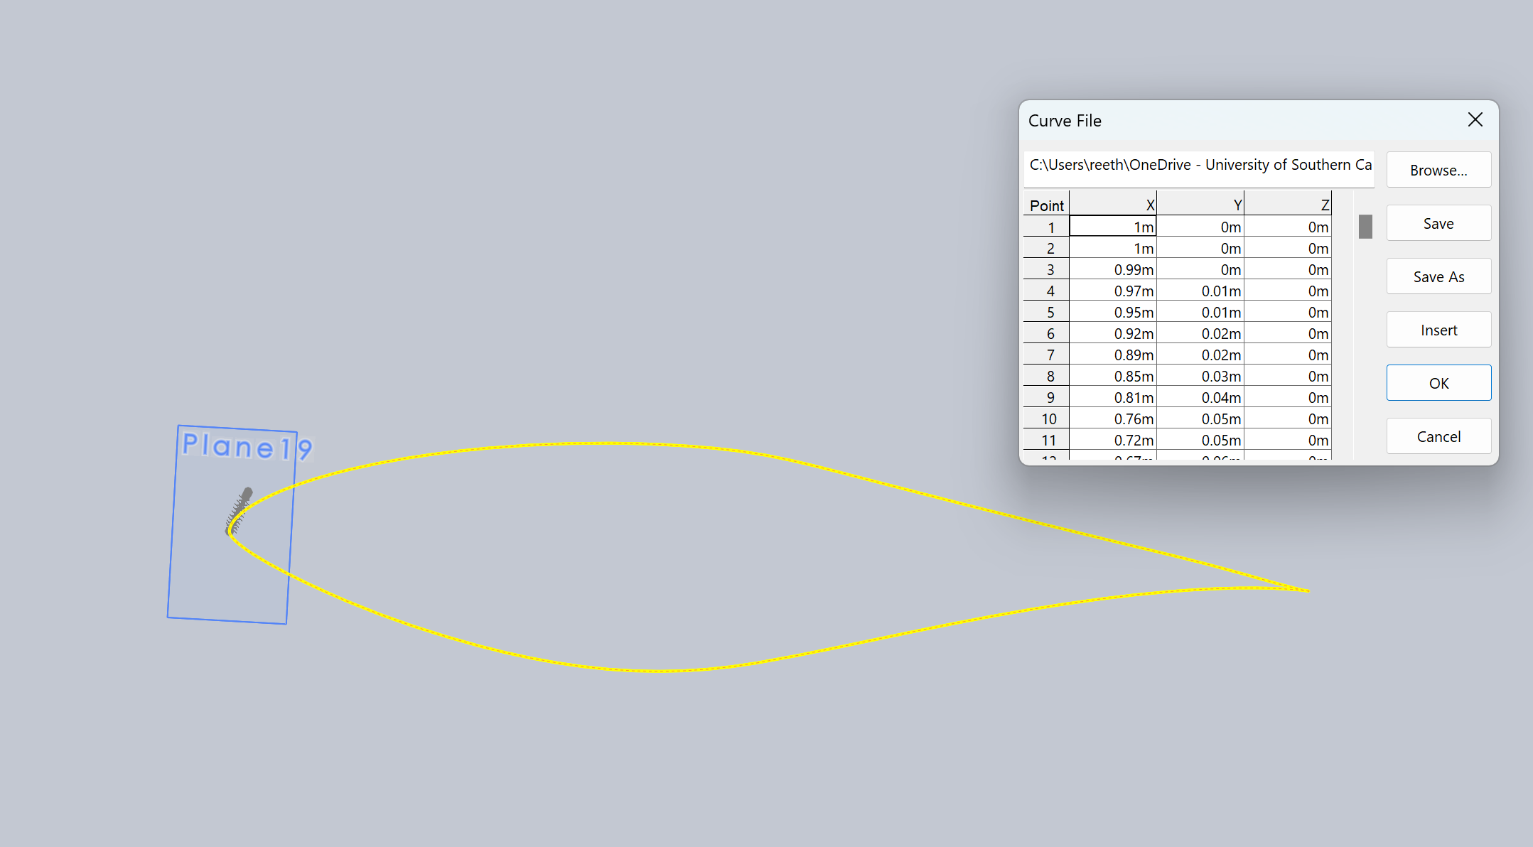

*Figure 16. Airfoil S809 sketch in Solidworks*

The airfoil used to design this wind blade is NREL S809. It has a maximum thickness of 21% at 39.5% chord, and maximum camber is 1% at 82.3% chord. Figure 16. depicts S809 imported in Solidworks, a CAD (Computer Aided Design) software.

S809 is a widely used airfoil for horizontal-axis wind turbine blade design. It has a thick profile compared to other high-performance airfoils, making it suitable for structural robustness. Its camber contributes to lift-producing characteristics. It is designed in a way to maintain laminar flow over the upper surface, reducing drag and improving overall efficiency.   
It is suited for low to moderate wind speeds, steady wind conditions, smaller wind turbines and low Reynolds numbers. The max Cl/Cd at Re = 200,000 at an angle of attack 7.25o is 53.9.

* 1. **Design Process**

The airfoil is the shape at the cross section. Many blades use a different model of airfoil at different section for the highest power output. For this blade, we utilize only one type of airfoil because of its short length.

As previously discussed in Section 4.2.2., the tip region has the shortest chord length, the intermediate region has a moderately long chord length and the root primarily deals with torsional loads, hence has the largest chord length.

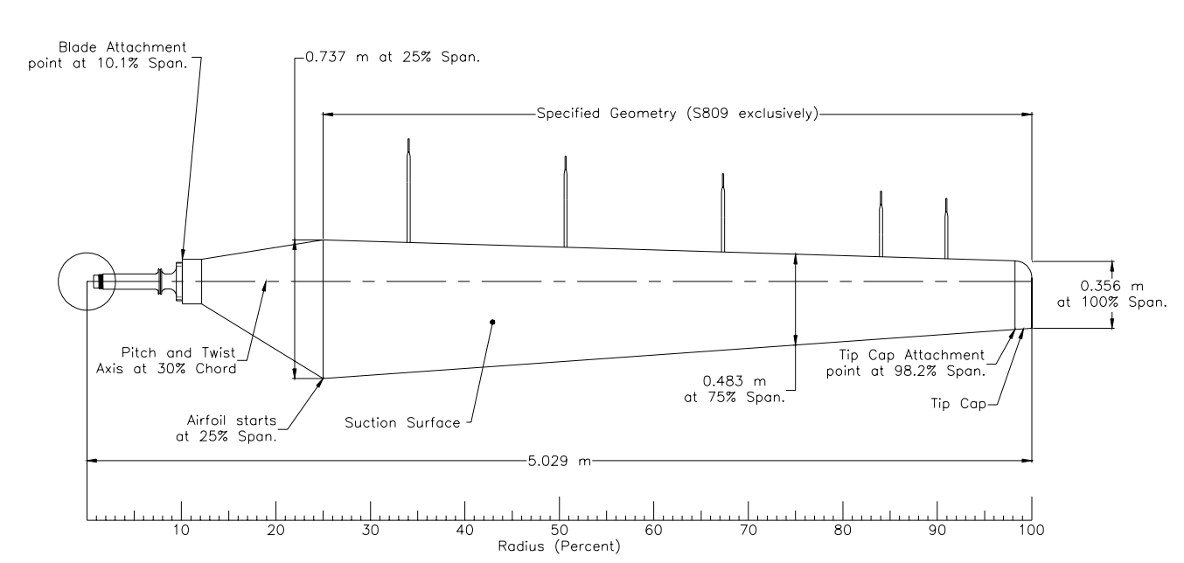

*Figure 17. Side view of blade*

Table 2. *Position of each cross section*

|  |  |  |
| --- | --- | --- |
| Point on span | Scale | Twist angle |
| 25% | 0.737 | 19 |
| 35% | 0.686 | 12 |
| 45% | 0.635 | 5.5 |
| 55% | 0.585 | 2 |
| 65% | 0.534 | 1.9 |
| 75% | 0.483 | 1 |
| 90% | 0.407 | -0.75 |
| 100% | 0.356 | -2 |

Table 2 data is obtained from a study conducted by NREL on Unsteady Aerodynamics Experiment Phase VI as expressed in Figure 17. The blade in Figure 18. is built based on these parameters. Each cross section is connected at the leading edge unlike like the NREL study.

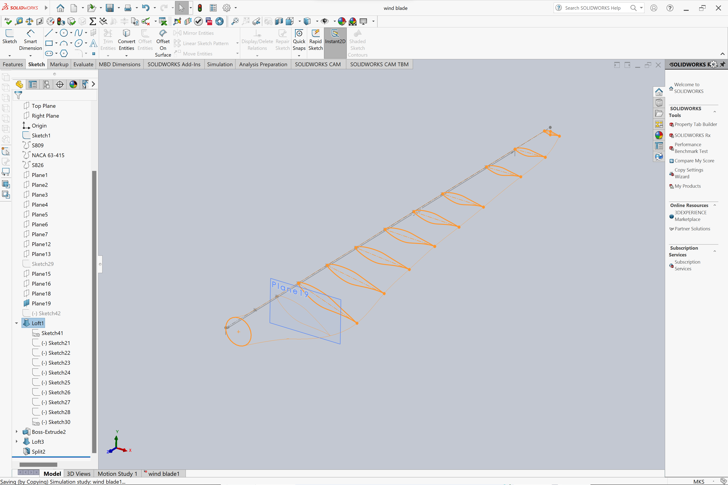

*Figure 18. CAD design with each cross section, right-top view*

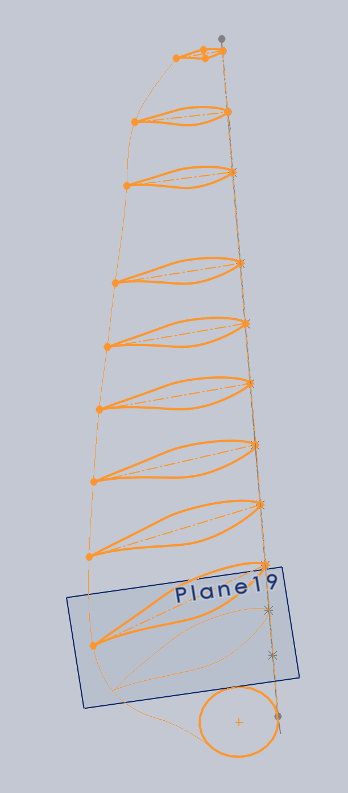

*Figure**19. Front-top view*

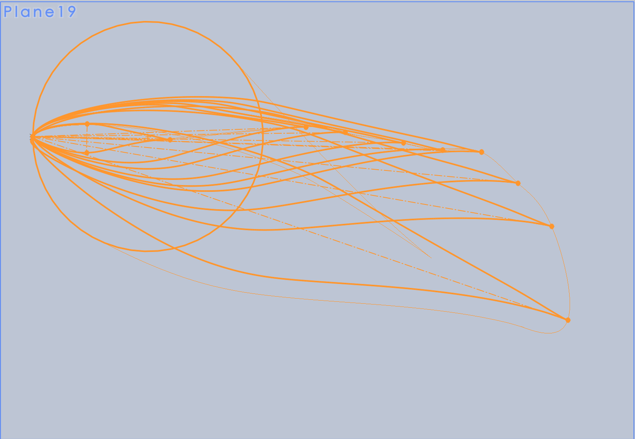

*Figure 20. Front view*

A boss extrusion from the circular face, the first cross section is boss extruded to fit into the rotor.   
Figure 18, 19 and 20. show different views of the blade. From these images we can see the how the twist angles vary relative to each other. After drawing the sketch at different intersections, A loft base is extruded to each cross section, and it takes the shape of Figure 21. and 22.

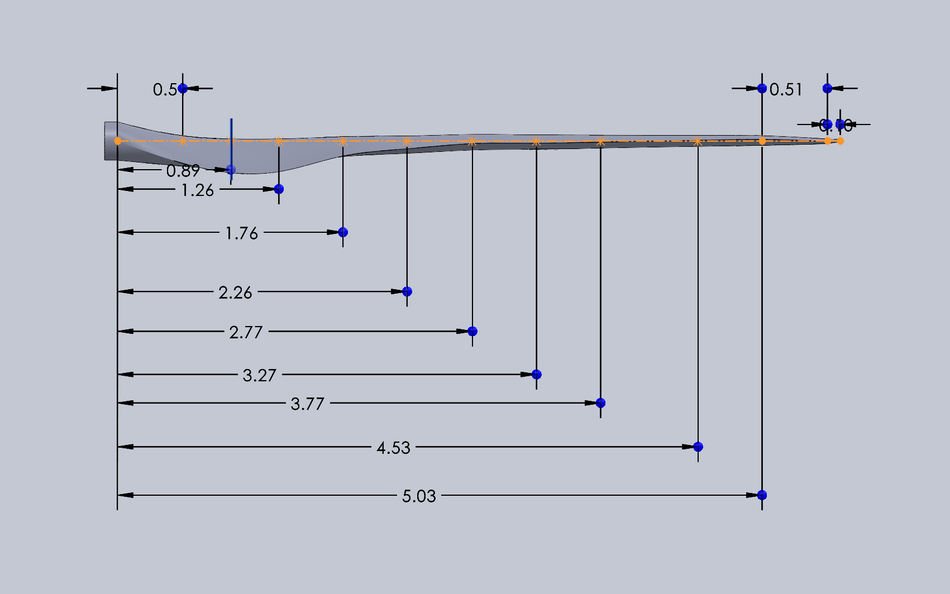

*Figure 21. Side view with dimensions*

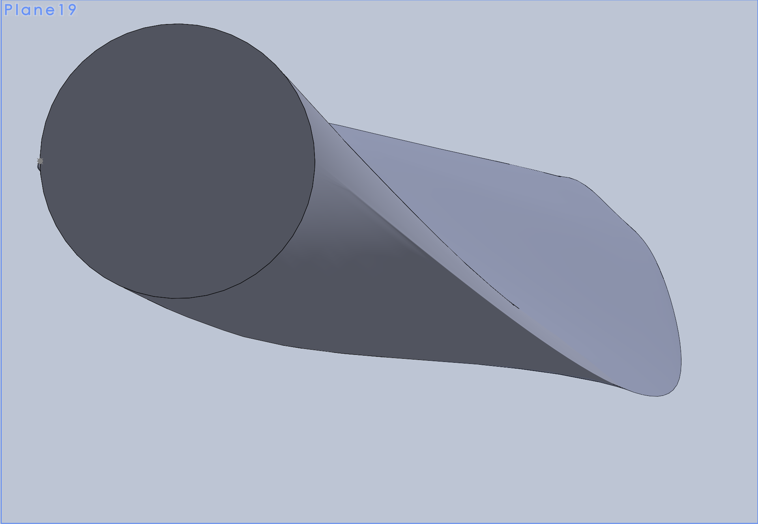

*Figure 22. Front view of the solid model of the blade*

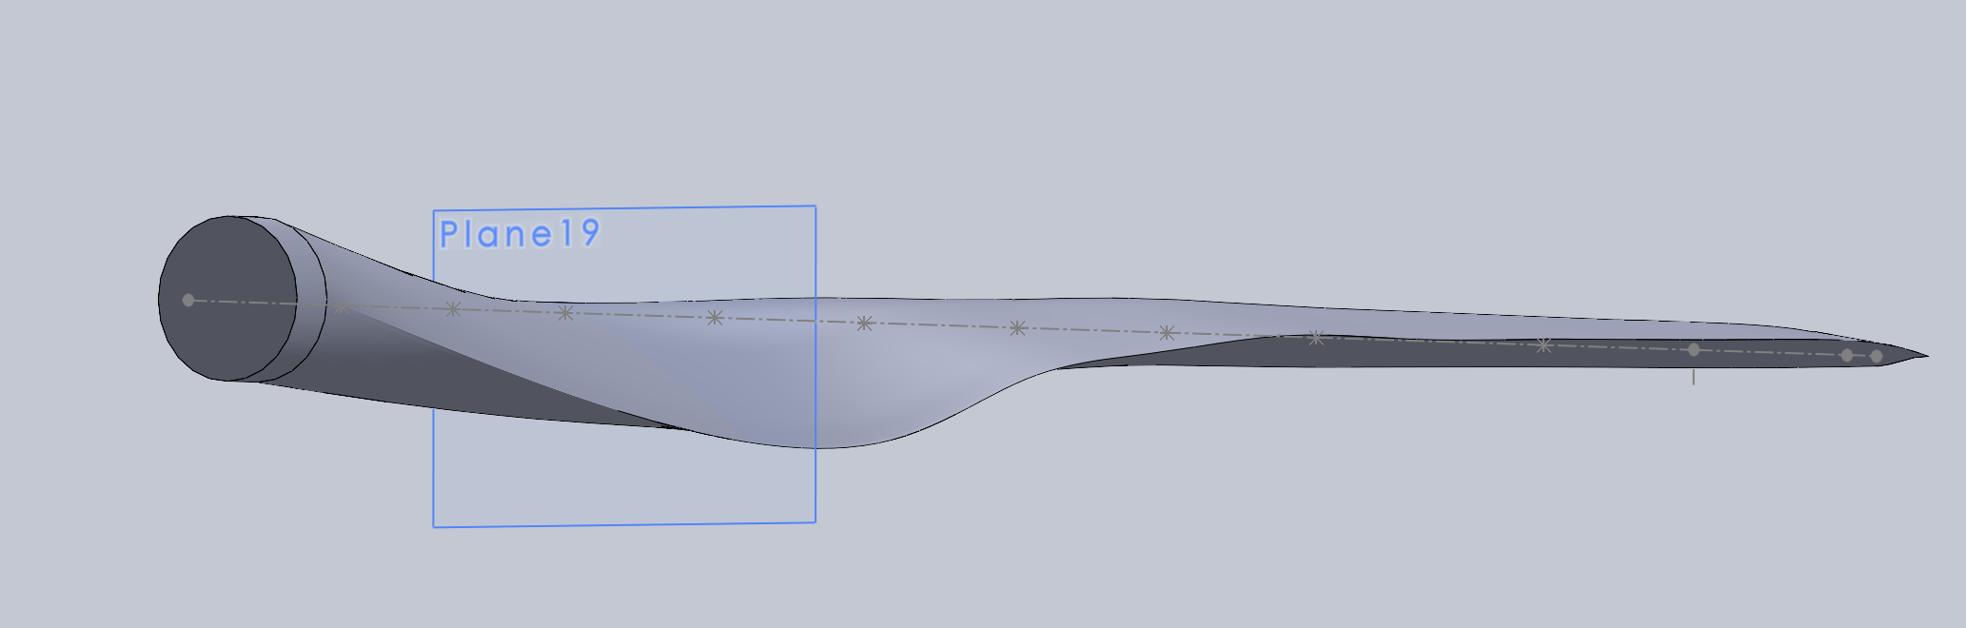

*Figure 23. Side view of the solid model of the blade*

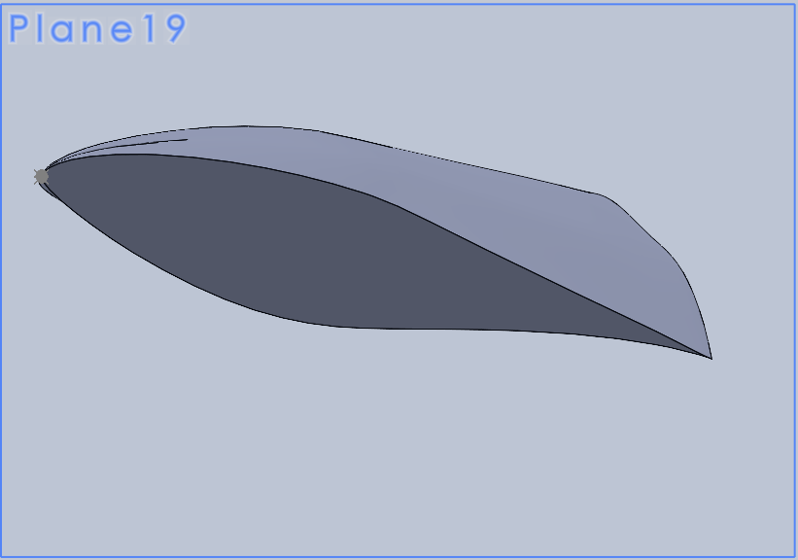

*Figure 24. Sectional view of the blade*

**7.0. ANALYSIS**

**7.1. Setup**

Analysis of wind turbine blades is crucial to ensure they perform optimally and safely. Wind blade analysis assesses their structural integrity, aerodynamic efficiency, and response to various loads. Tools like ANSYS are used to simulate real-world conditions and assess blade behavior. The static structural method, a subset of analysis, predicts blade deformations and stresses under different loads. This method helps identify potential structural issues, ensuring the blade can withstand wind forces without excessive deflection or damage. Results from static structural analysis provide insights into blade reliability and safety, helping engineers refine designs and materials. ANSYS is preferred for its accuracy in predicting blade performance and its ability to simulate diverse operating conditions. Ultimately, this analysis contributes to the development of more efficient, durable, and cost-effective wind turbine blades, advancing the renewable energy industry.

The aim of the analysis is to find the maximum load case, a simplified summation of the loads a wind blade experiences. It is then compared to the ultimate yield stress to understand the efficiency of the blade and how it could be optimized.

The flowchart in Figure 25. expedites the list of steps to run a successful analysis.

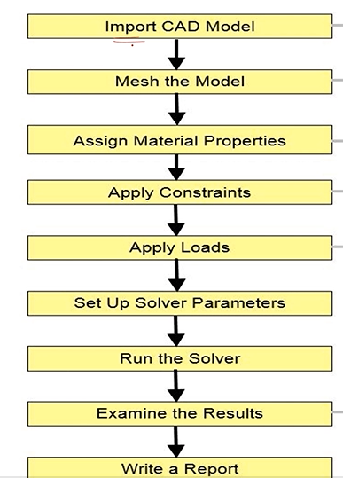

*Figure 25. Flowchart to setup Ansys simulation*

After importing the CAD model, the material data of E glass is entered in the workbench. The material data is depicted in Figure 26. Since it is a small blade and the report covers static structural analysis by applying moments in XYZ directions, a material with isotropic properties is considered. It makes it easy to analyze the wind turbine blade and define point of failure.

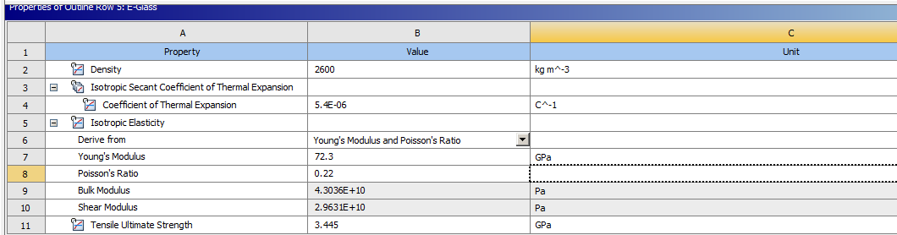

*Figure 26. E glass properties*

The next step is to align the coordinate system appropriately. A coordinate system provides a frame of reference that helps specifying where loads, boundary conditions and material properties are applied. It helps avoid errors related to misalignment or incorrect orientation of loads and constraints. When reviewing analysis results, a coordinate system provides a reference for understanding the orientation of deformations, stresses and strains.

The X direction is along edgewise moment, the Y direction is along the flapwise moment and Z is the direction of bending moments. This coordinate system is devised so when later applying the moments, it indicates the defines the magnitude of the moment.

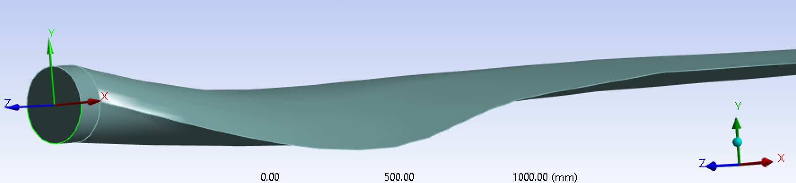

*Figure 27. Coordinate system of the wind blade*

Since a simple static analysis is going to be run, an approximate combination of all the loads is applied at the center of mass. Before we begin to apply the loads, a remote point at the center of mass is created. A hex mesh is then generated on the wind blade as depicted in Figure 28.

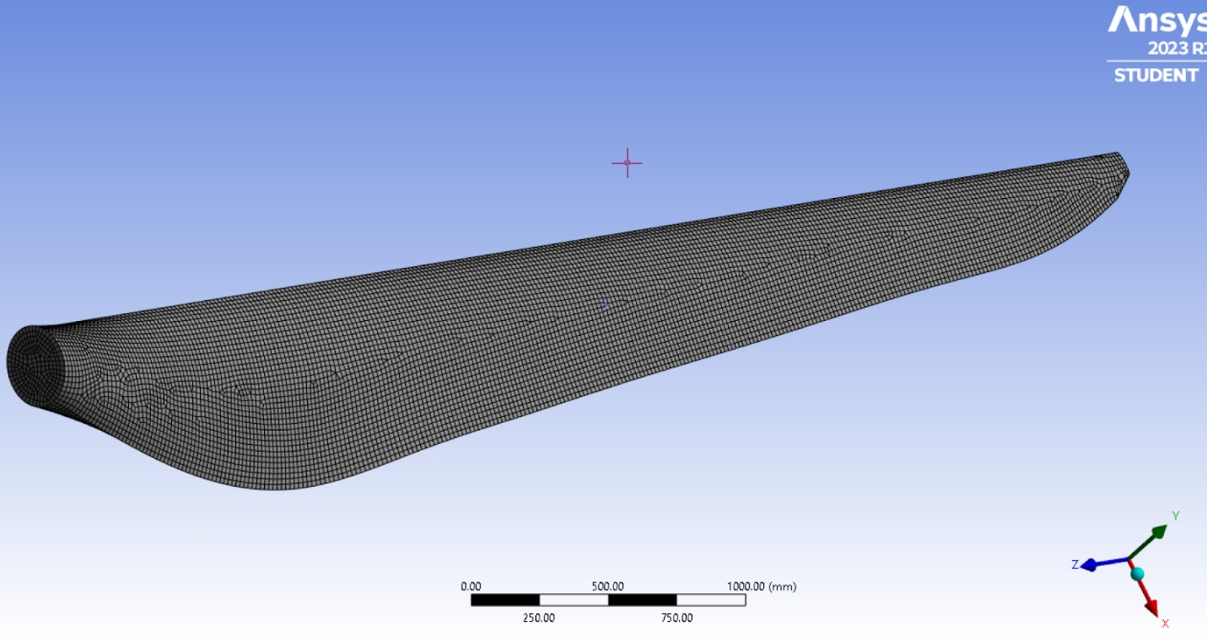

*Figure 28. Mesh model of the wind blade*

The results accounted for are total deformation and equivalent stress. In ANSYS results, "Total Deformation" and "Equivalent Stress" provide valuable information about how a structure or component responds to applied loads and boundary conditions:

1. Total Deformation tells us how much a structure deforms due to applied loads and constraints. Excessive deformation can indicate potential structural issues, such as excessive stresses or insufficient stiffness.
2. Equivalent Stress, also known as von Mises stress, provides a single value that represents the combined effect of various stress components at different orientations within the material. It helps us determine if the material is likely to fail under the applied load. A high equivalent stress indicates concern for potential failure.

By examining these results, engineers can identify areas that may require design modifications to improve performance or safety.

**7.2. Simulation**

The results of six load cases to understand maximum and minimum moments in X, Y and Z orientations are presented in table 2. Each load case has a +z and -z to understand how much the results change with a change in the direction of moment z. These values are approximate values provided by Mr. Paramasivan, NIWE certification engineer. While adding a force, it is important to fix the face of blade, where rotor is attached, to get accurate results.

Table 3. *Moment load case with results*

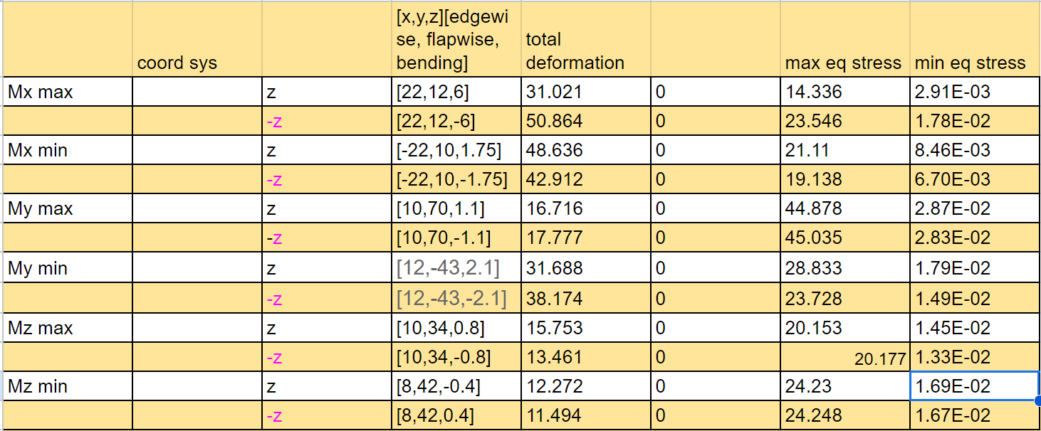

All figures 29 to 40 below show the total deformation and equivalent stress results for the maximum and minimum of Moments in x, y and z directions, for the values of the -z from Table 3.

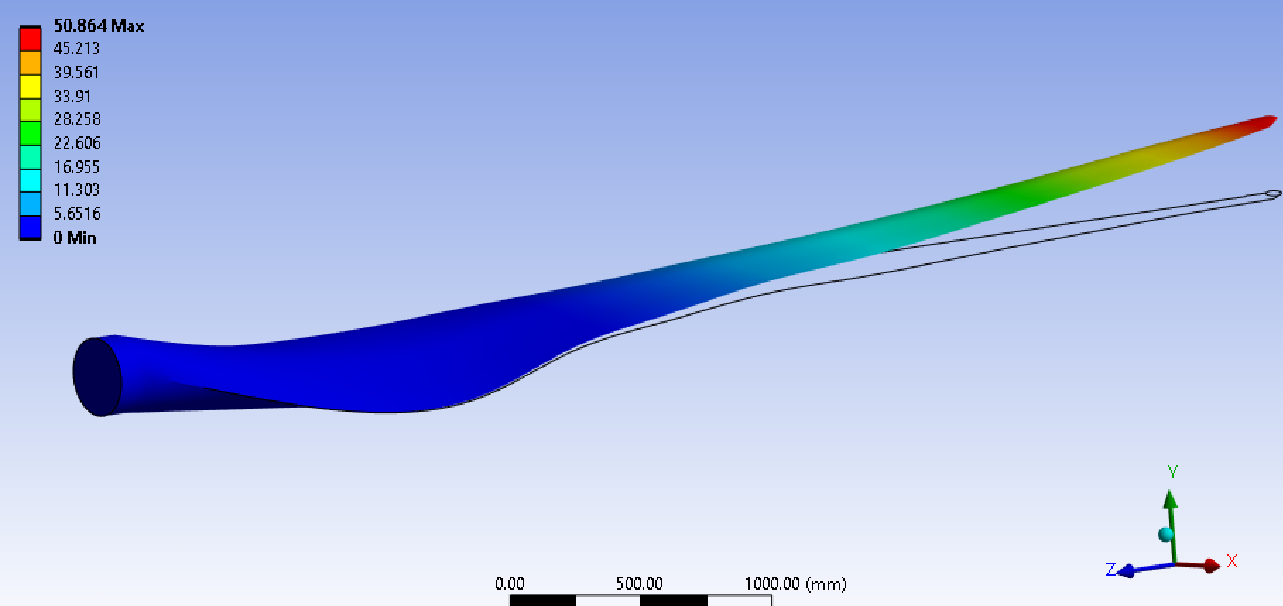

*Figure 29. Total deformation for Moment-x max*

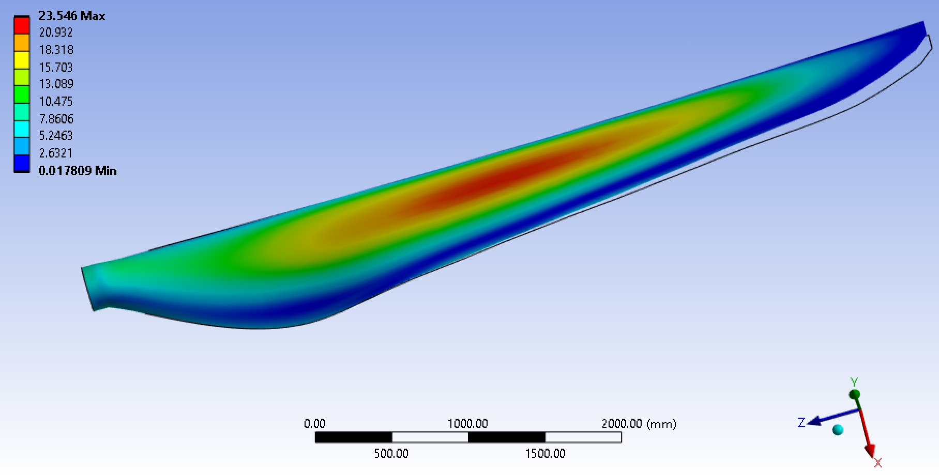

*Figure 30. Eq. stress for Moment-x max*

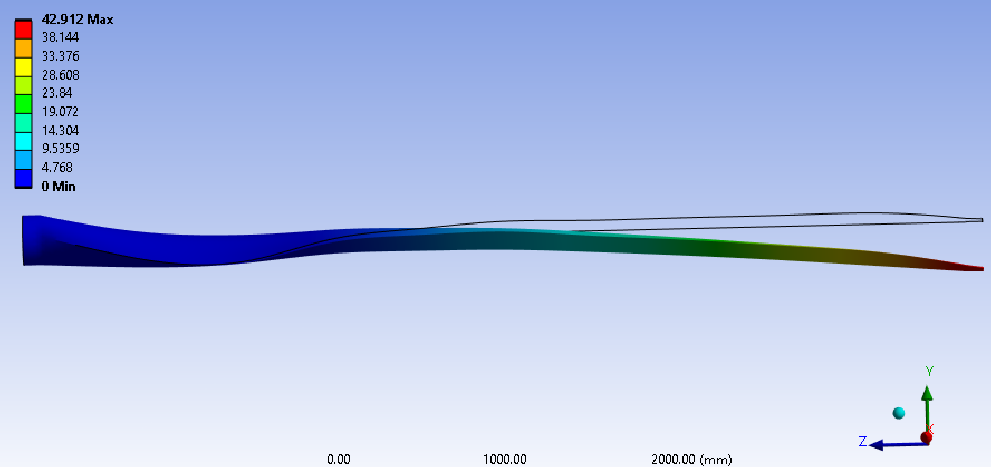

*Figure 31. Total deformation for Moment-x min*

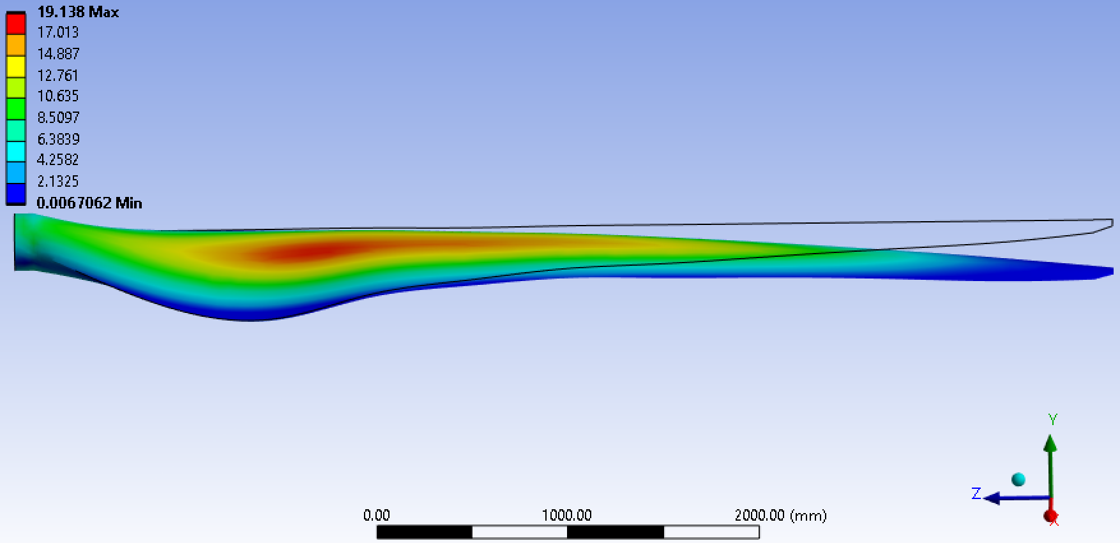

*Figure 32. Eq. stress for Moment-x min*

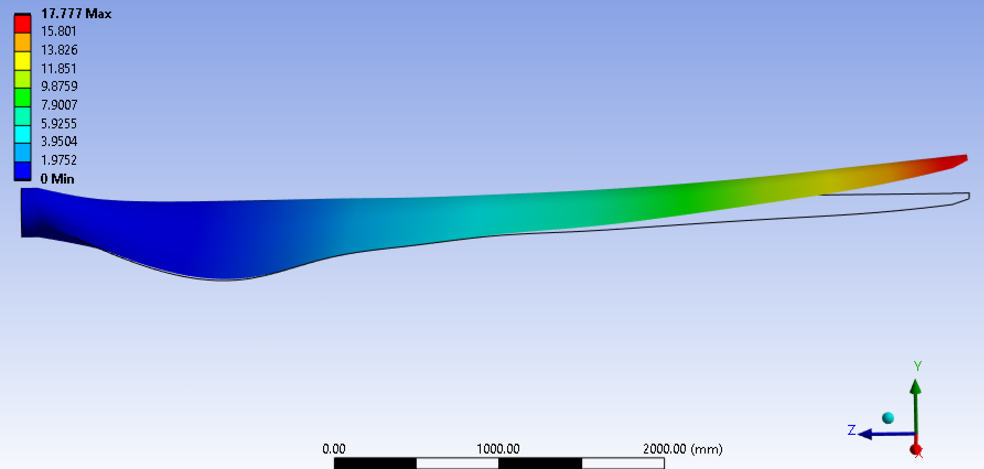

*Figure 33. Total deformation for Moment-y max*

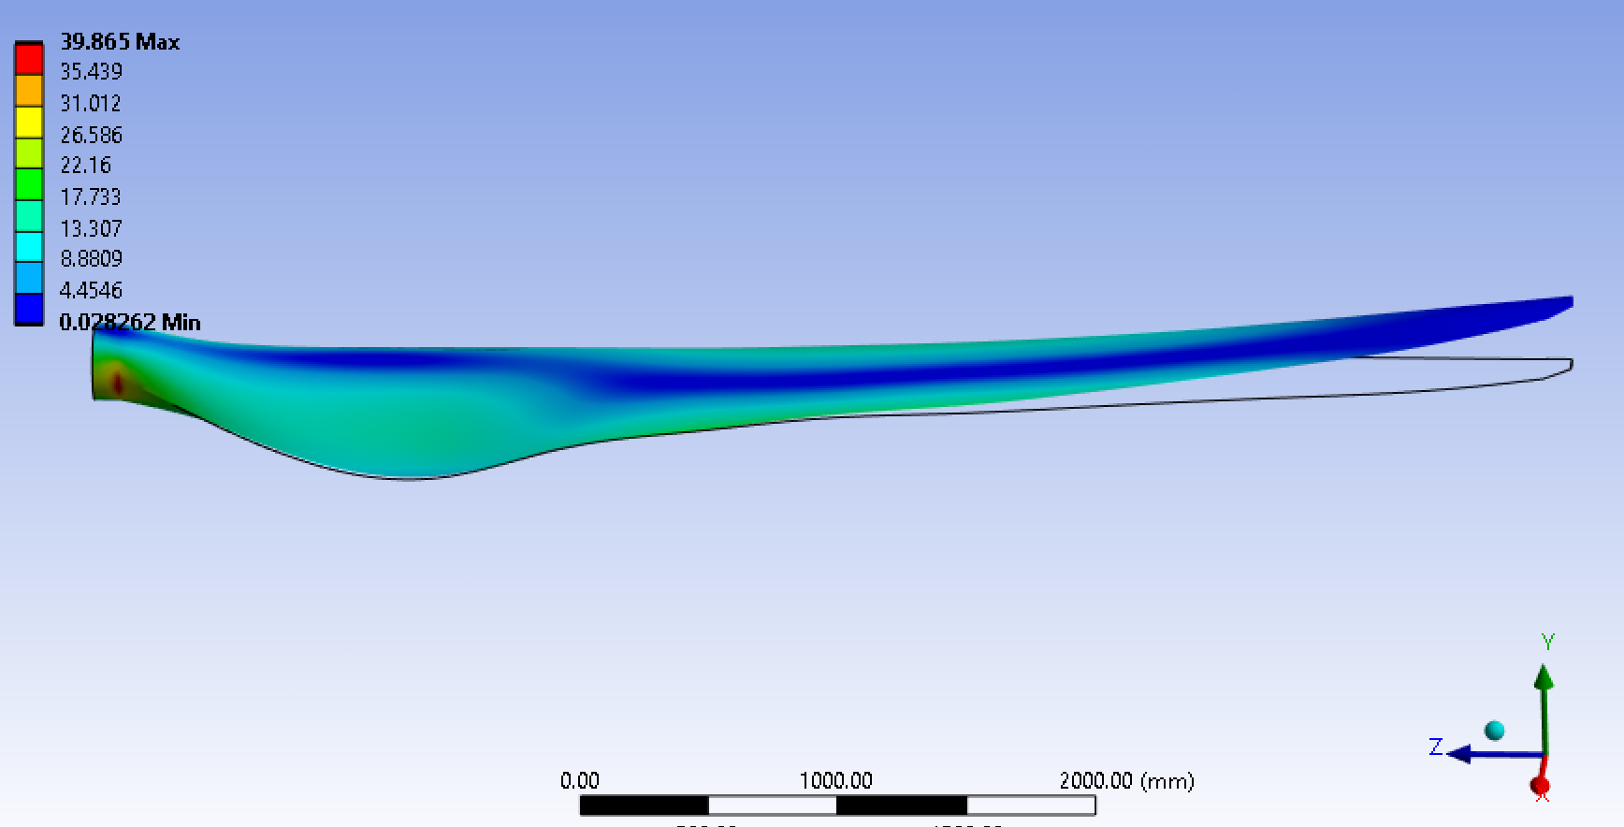

*Figure 34. Eq. stress for Moment-y max*

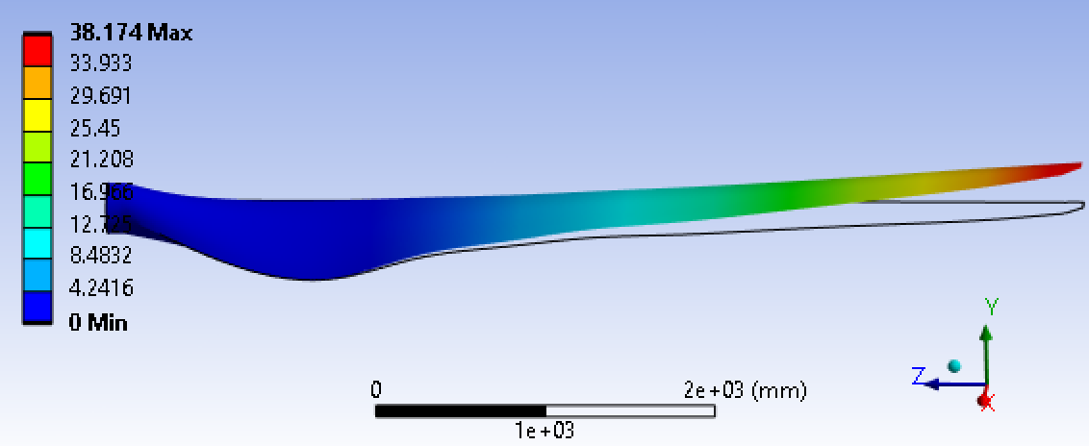

*Figure 35. Total deformation for Moment-y min*

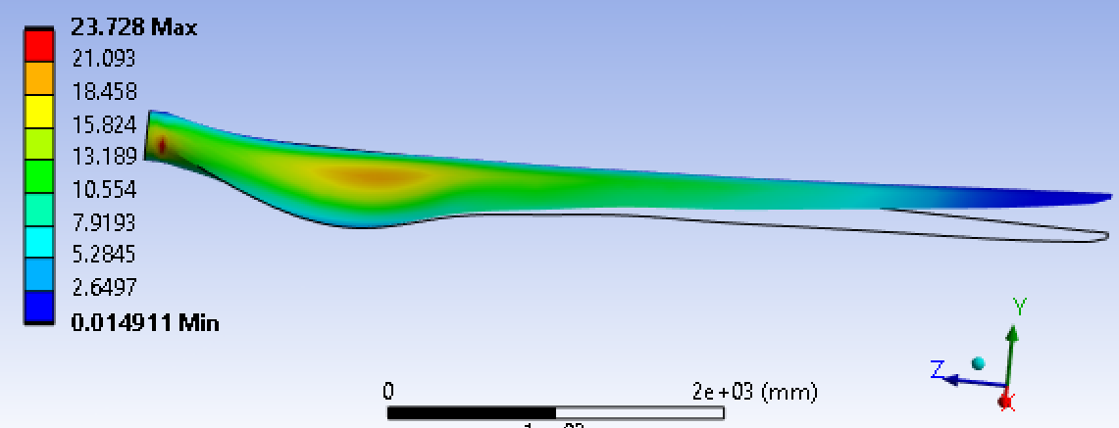

*Figure 36. Eq. stress for Moment-y min*

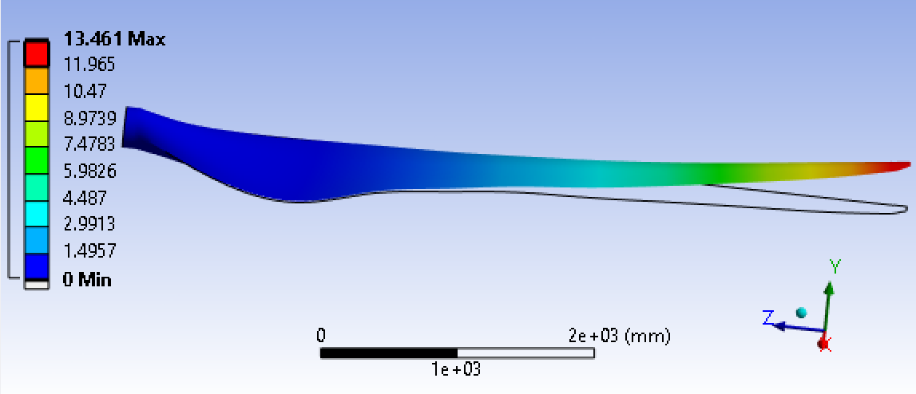

*Figure 37. Total deformation for Moment-z max*

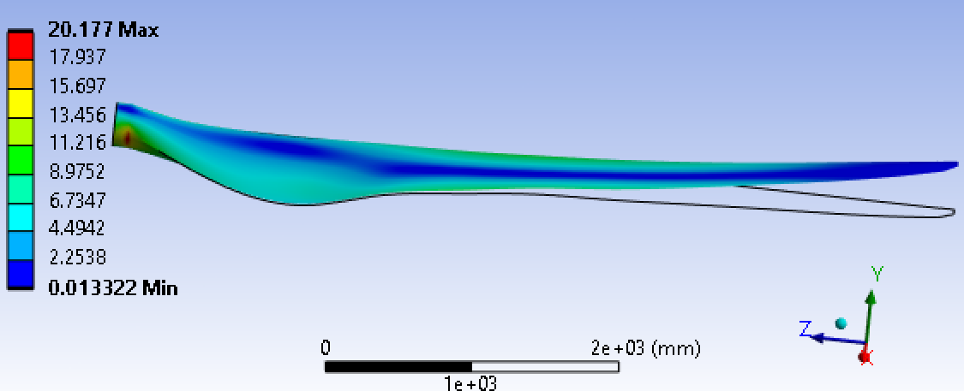

*Figure 38. Eq. stress for Moment-z max*

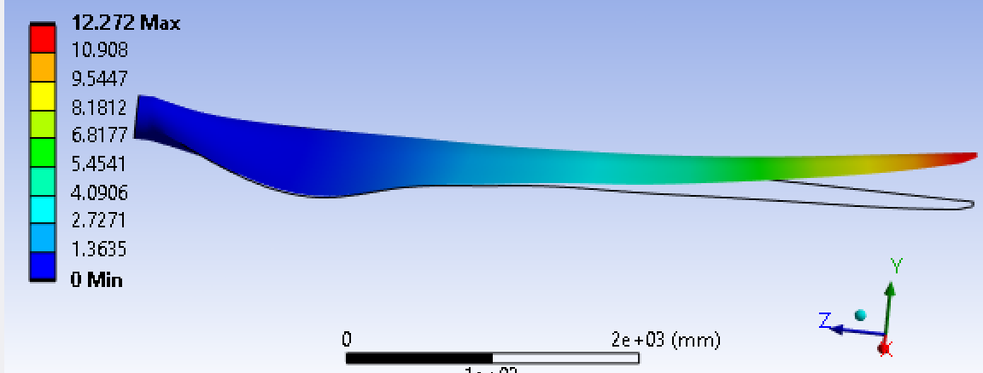

*Figure 39. Total deformation for Moment-z min*

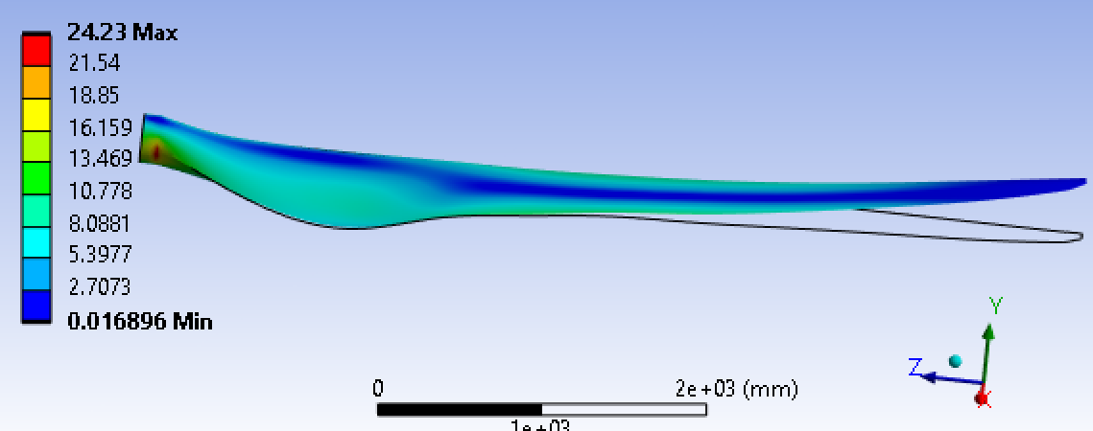

*Figure 40. Eq. stress for Moment-z min*

**7.3. Observations and Results**

All deformations are gradient from root to tip, with tip experiencing maximum deformation at Moment-x max load case equal to 50.864mm. A blade is considered to fail when total deformation reaches 10% of the span length.

Since the blade is fixed at the rotor, minimum total deformation is always zero. The total deformation is maximum at the highest value of moment(x) and varies along with moment(z) as well. It is lowest for the lowest values of a combination of moment(x) and moment(z). Even high values of moment(y) do not affect the total deformation.

For moment-x maximum and minimum load cases, the equivalent stress gradient concentrates from outwards to inwards. For other load cases, the maximum stress is focused on circular frame of the design, at the intersection of the boss extrusion and loft base. In case moment(y) minimum, the stress is maximum at the longest chord length and minimum at the tip. It decreases radially outward. Moment-z load cases have the least stress along the pitch axis from root to tip lengths, and it decreases at the leading and trailing edges. The average maximum equivalent stress is 45.035 MPa in moment(y) max load case. This is an ideal result because flap-wise bending is the highest moment force a blade experiences.

*Table 4. Experimental load cases*

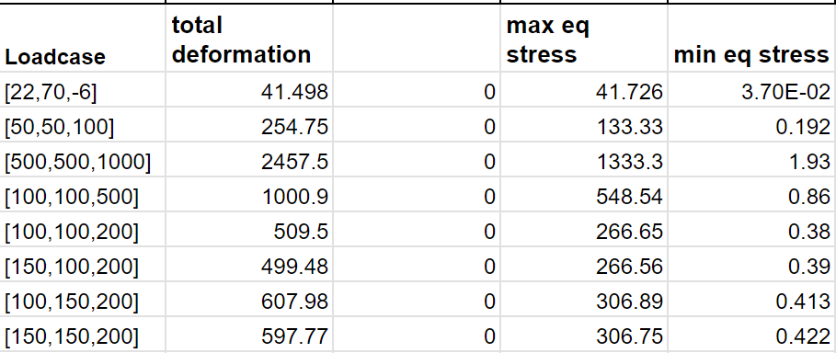

The load cases in table 4 are experimental data runs to analyze the maximum summation of loads the design blade can take. The total deformation is in mm and the equivalent stress is measured in MPa. Observations from these runs are as follows:

Ideally deformation should be 570mm when equivalent stress reaches around 1600MPa but the blade reaches maximum deformation at 16% of required stress value, the ultimate yield stress of the material. The value of the blade’s equivalent stress in response to different load cases is compared with the material’s yield stress. An efficient blade should be able to tolerate stress equal to yield stress. The material used has a yield stress equal to 3.445 GPa. The observation depicts design faults and scope for improvement. This is the observation from case 5.

From case 6 when edgewise moment is increased from case 5, deformation decreases, and maximum equivalent stress decreases negligibly.

Upon increasing the flap-wise moment from case 5 to case 7, we observe that deformation almost doubles and maximum equivalent stress increases less than double.

Upon increasing both flap-wise and edgewise moments from case 5 to case 8, the deformation increases, and stress increases less than case 7. This case provides results as a combination of cases 6 and 7.

**8.0. CONCLUSION:**

The field of wind energy and wind turbine technology is a testament to human ingenuity and innovation. From the fundamental principles of aerodynamics to the intricacies of blade design, materials science, and structural analysis, wind turbine engineering represents a harmonious blend of science, engineering, and environmental consciousness.

The selection of airfoils, such as the S809, for various blade regions, underscores the importance of tailoring designs to specific performance requirements. Understanding factors like Reynolds numbers, blade solidity, and twist angles enables engineers to create turbines that extract maximum energy from the wind while maintaining structural integrity.

The use of advanced software like ANSYS for structural analysis and simulations further exemplifies the technological advancements in the industry. These tools allow engineers to assess and refine designs, ensuring they withstand the harsh forces of nature while optimizing power output.

Furthermore, the growth of wind energy is not only about technical excellence but also environmental responsibility. Wind turbines are becoming larger and more efficient, harnessing the power of the wind to generate clean, sustainable electricity on an unprecedented scale.

**9.0. REFERENCES**

1. *(PDF) Experimental Analysis of an S809 Airfoil - Researchgate*, www.researchgate.net/publication/271765013_Experimental_Analysis_of_an_S809_Airfoil. Accessed 5 Sept. 2023.
2. *(PDF) Experimental Analysis of an S809 Airfoil - Researchgate*, www.researchgate.net/publication/271765013_Experimental_Analysis_of_an_S809_Airfoil. Accessed 5 Sept. 2023.
3. “Airfoil Tools.” *Airfoil Tools*, airfoiltools.com/. Accessed 4 Sept. 2023.
4. “How a Wind Turbine Works - Text Version.” *Energy.Gov*, www.energy.gov/eere/wind/how-wind-turbine-works-text-version. Accessed 4 Sept. 2023.
5. “How to Design Wind Turbine Blade Geometry for Optimal Aerodynamic Efficiency.” *YouTube*, YouTube, 10 Nov. 2020, www.youtube.com/watch?v=CavfXOt3Dew.
6. *Materials for Wind Turbine Blades: An Overview - PMC*, www.ncbi.nlm.nih.gov/pmc/articles/PMC5706232/. Accessed 5 Sept. 2023.
7. *Niwe*, niwe.res.in/assets/Docu/WT_Rotors_or_Blades_to_be_Optimized_for_Low&Moderate_Wind_Regimes_CSIR-NAL.pdf. Accessed 5 Sept. 2023.
8. *NREL’s S809 Airfoil (S809-NR)*, airfoiltools.com/airfoil/details?airfoil=s809-nr. Accessed 4 Sept. 2023.
9. *Optimized Carbon Fiber Composites in Wind Turbine Blade Design*, www.energy.gov/sites/prod/files/2019/12/f69/SAND2019-14173-Optimized.pdf. Accessed 5 Sept. 2023.
10. *Physical and Mechanical Properties of Glass Fiber ... - Researchgate*, www.researchgate.net/figure/Physical-and-mechanical-properties-of-glass-fiber_tbl2_265346634. Accessed 5 Sept. 2023.
11. *Shape Model of the NREL Phase VI Wind Turbine Blade.*, www.researchgate.net/figure/Shape-model-of-the-NREL-Phase-VI-wind-turbine-blade_fig1_257774740. Accessed 5 Sept. 2023.
12. *Static Analysis of a Composite Wind Turbine Blade Using Finite Element ...*, upcommons.upc.edu/bitstream/handle/2117/332161/Marine-2017-92_STATIC%20ANALYSIS%20OF%20A%20COMPOSITE.pdf?sequence=1. Accessed 5 Sept. 2023.
13. *Unsteady Aerodynamics Experiment Phase VI: Wind Tunnel Test ... - NREL*, www.nrel.gov/docs/fy02osti/29955.pdf. Accessed 5 Sept. 2023.